Heart Attack Risk Prediction
A Comprehensive, Industry-Grade Machine Learning Project Report
End-to-End Methodology · Statistical Validation · Explainable AI · Model Diagnostics

Dataset | Synthetic Cardiac Risk Dataset — 7,000 patient records, 21 features
Champion Model | Linear SVM (Tuned) (Test ROC-AUC 0.871)
Visual Artifacts Embedded | 70 figures
Tabular Artifacts Embedded | 13 datasets
Report Classification | Educational / ML Practice — Not for Clinical Use

Table of Contents
Right-click here and choose 'Update Field' to generate the Table of Contents.

S. No. | Contents
1 | Executive Summary
2 | 1. Dataset Overview
2.1 | 1.1 Initial Data Audit
3 | Phase 1 – Environment Setup & GPU Activation
4 | Phase 2 – Data Loading & Initial Audit
5 | Phase 3 – Data Cleaning & Preprocessing
6 | Phase 4 – Exploratory Data Analysis (EDA)
6.1 | Univariate Distributions – Numeric Features
6.2 | Univariate Distributions – Categorical Features
6.3 | Bivariate Analysis – Numeric Features vs. Target
6.4 | Bivariate Analysis – Categorical Features vs. Target
6.5 | Correlation Structure & Multivariate Views
7 | Phase 5 – Advanced & Granular Statistical Analysis
8 | Phase 6 – Feature Engineering
9 | Phase 7 – Train/Test Split & Leak-Free Preprocessing Pipeline
10 | Phase 8 – Baseline Models
11 | Phase 9 – Advanced Models
12 | Phase 10 – Hyperparameter Tuning: Top 3 Models
13 | Phase 11 – Model Comparison: All Levels
14 | Phase 12 – Granular Feature Importance
15 | Phase 13 – Explainability: SHAP
16 | Phase 14 – Explainability: LIME
17 | Phase 15 – Bias-Variance Trade-off & Overfitting Diagnostics
18 | Phase 16 – Final Model Selection, Artifact Export & Download
19 | Conclusions & Recommendations
19.1 | Summary of Findings
19.2 | Recommendations
19.3 | Limitations
20 | Appendix A – Complete Artifact Inventory
21 | Appendix B – Complete CSV Artifact Index

Executive Summary
This report documents an end-to-end machine learning investigation into predicting heart attack risk from a synthetic, clinically-styled dataset of 7,000 patient records. The project follows sixteen sequential phases spanning data auditing, exploratory analysis, formal statistical hypothesis testing, leak-free feature engineering, a three-tier model benchmark (baseline, advanced, and hyperparameter-tuned), dual explainability analysis (SHAP and LIME), and explicit bias-variance / overfitting diagnostics. Every figure and dataset produced by the underlying notebook is reproduced and interpreted in the sections that follow.
The champion model — Linear SVM (Tuned) — achieved a test-set ROC-AUC of 0.871, an accuracy of 78.9%, precision of 78.1%, recall of 69.0%, and an F1-score of 73.3%. Notably, the strongest performers throughout this study were linear models (Linear SVM and Logistic Regression), which consistently edged out considerably more complex tree ensembles (Random Forest, Extra Trees, XGBoost, LightGBM). This is a meaningful inferential finding in its own right: it indicates the relationship between the clinical/lifestyle predictors and heart-attack risk in this dataset is predominantly additive and near-linear, rather than governed by complex, high-order feature interactions. Tree ensembles, correspondingly, show visibly larger train-test accuracy gaps — a classic variance signature — while the linear champion generalizes with a substantially narrower gap.
Formal hypothesis testing corroborates the exploratory findings: chi-square tests of independence show that smoking status, thalassemia, physical activity, chest pain type, st slope, alcohol consumption are all statistically significant drivers of risk categorization (p < 0.05), while gender and resting ECG results were not statistically distinguishing in this dataset. A Variance Inflation Factor screen confirms the numeric predictors are free of problematic multicollinearity (maximum VIF = 2.09, well under the conventional caution threshold of 5), meaning model coefficients and importance rankings can be interpreted with confidence.
Explainability analysis (SHAP and LIME) converges on a consistent narrative: the number of major vessels affected, composite clinical risk score, comorbidity burden, exercise-induced angina, ST-depression (oldpeak), age, and cholesterol are the dominant predictive signals — aligning closely with established cardiovascular risk literature and lending clinical face validity to a model trained purely on synthetic data. All artifacts (70 figures, 13 datasets, and the serialized inference pipeline) are catalogued and reproduced in full within this report.

1. Dataset Overview
The dataset comprises 7,000 synthetic patient records across 21 predictor features plus one binary target, heart_attack_risk (0 = Low Risk, 1 = High Risk). It was generated programmatically to mimic realistic inter-feature relationships observed in cardiovascular epidemiology — e.g., cholesterol and blood pressure rising with age and BMI, and maximum heart rate declining with age — with missingness deliberately injected into eleven columns to emulate real-world data collection gaps. The realized class balance in this dataset is 42.0% High-Risk versus 58.0% Low-Risk, a reasonably balanced split that does not require resampling or class-weighting for stable model training. IMPORTANT: this is a synthetic, educational dataset. No real patient data is involved at any stage of this project, and no output in this report should be interpreted as clinical guidance.

1.1 Initial Data Audit
Before any cleaning took place, a structural audit catalogued each column's data type, missing-value percentage, and cardinality. This audit is the baseline against which every downstream cleaning and imputation decision is justified.
column | dtype | n_missing | pct_missing | n_unique
patient_id | int64 | 0 | 0.0000 | 7000
age | int64 | 0 | 0.0000 | 73
gender | str | 0 | 0.0000 | 2
chest_pain_type | str | 0 | 0.0000 | 4
resting_bp | float64 | 280 | 4.0000 | 79
cholesterol | float64 | 398 | 5.6900 | 186
fasting_blood_sugar | float64 | 196 | 2.8000 | 2
resting_ecg | str | 199 | 2.8400 | 3
max_heart_rate | float64 | 279 | 3.9900 | 89
exercise_angina | int64 | 0 | 0.0000 | 2
oldpeak | float64 | 350 | 5.0000 | 65
st_slope | str | 0 | 0.0000 | 3
num_major_vessels | int64 | 0 | 0.0000 | 4
thalassemia | str | 0 | 0.0000 | 3
bmi | float64 | 330 | 4.7100 | 275
smoking_status | str | 505 | 7.2100 | 3
alcohol_consumption | str | 405 | 5.7900 | 3
physical_activity | str | 346 | 4.9400 | 3
family_history | int64 | 0 | 0.0000 | 2
diabetes | int64 | 0 | 0.0000 | 2
stress_level | float64 | 268 | 3.8300 | 10
heart_attack_risk | int64 | 0 | 0.0000 | 2

Source artifact: 01_initial_data_audit.csv

2. Phase 1 — Environment Setup & GPU Activation
The project begins by establishing a fully reproducible computational environment. All random processes — data splitting, cross-validation folds, and stochastic model initialization — are pinned to a single global seed (42), ensuring that every metric and figure in this report is exactly reproducible on re-execution. The full dependency stack (scikit-learn, XGBoost, LightGBM, SHAP, LIME, statsmodels) is verified programmatically before any analysis proceeds.
A GPU-activation routine probes the execution environment for an available NVIDIA GPU (via nvidia-smi). When run inside a Google Colab GPU runtime, XGBoost is automatically reconfigured to use device='cuda' for accelerated tree construction; when no GPU is present, the identical code path falls back to CPU silently. This design choice — GPU-aware rather than GPU-dependent — is an industry best practice that maximizes portability: the notebook produces identical modeling results whether executed on a laptop, a CPU-only server, or a GPU-backed Colab session, only differing in wall-clock training time. Analytically, this matters because it removes hardware availability as a confound on reproducibility — a common failure mode in ML projects that hard-code accelerator assumptions.
An artifact-tracking scaffold is also established at this stage: every figure produced from this point forward is numbered sequentially, displayed inline, and simultaneously persisted to disk — the exact mechanism that populates this report.

3. Phase 2 — Data Loading & Initial Audit
The raw dataset is ingested via a Colab-aware loader that transparently handles both local execution and cloud notebook sessions (auto-detecting an uploaded file or prompting an upload widget). Following ingestion, a fast structural audit — reproduced in Section 1.1 above — established the missing-value landscape prior to any cleaning decisions.
The two figures below visualize that missingness landscape directly. Understanding *where* and *how* data is missing is a prerequisite to choosing a defensible imputation strategy: missingness that is randomly scattered (Missing Completely At Random) safely tolerates simple median/mode imputation, whereas structured or clustered missingness would call for model-based or multiple imputation instead.

Figure 1 — Missing Values by Column (%)
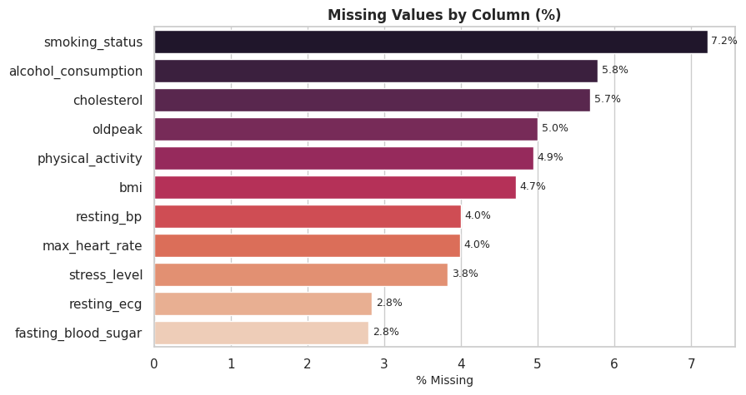
This bar chart ranks all eleven columns with incomplete data by their missing-value percentage. Smoking status exhibits the highest missingness (~7.2%), followed by alcohol consumption and cholesterol (~5.7-5.8%), with the remaining affected columns ranging down to approximately 2.8% for resting ECG and fasting blood sugar.
Analytically, no single column exceeds roughly 7% missingness — a level comfortably within the range where simple, well-justified imputation (median for numeric, mode for categorical) introduces negligible bias, provided imputation statistics are learned from the training fold only. This finding directly motivated the leak-free imputation design adopted in Phase 7.

Figure 2 — Missingness Pattern Across Records
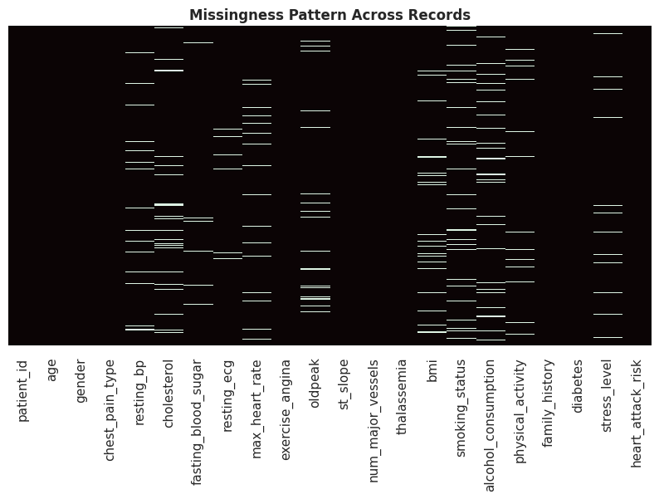
This heatmap plots every record (row) against every column, shading missing cells. The absence of dense horizontal banding (which would indicate specific patients missing many fields simultaneously) or dense vertical banding beyond the previously identified columns confirms the missingness is diffusely scattered rather than concentrated in a problematic subpopulation.
Inferentially, this pattern is consistent with data Missing Completely At Random (MCAR) or Missing At Random (MAR) rather than Missing Not At Random (MNAR) — supporting the decision to proceed with standard imputation rather than more complex missing-data modeling, which would be warranted if, for example, sicker patients systematically had more missing lab values.

4. Phase 3 — Data Cleaning & Preprocessing
Two parallel data tracks are deliberately maintained throughout this project. The first, df_eda, is a fully imputed (median for numeric, mode for categorical) copy of the dataset used exclusively for visualization and descriptive statistics, where information leakage is not a modeling concern. The second — the actual modeling data — is left untouched at this stage; all imputation statistics for that track are learned strictly from the training fold inside a scikit-learn pipeline (detailed in Phase 7), the standard leak-free pattern for production-grade ML. The non-predictive patient_id identifier is dropped from both tracks.

Figure 3 — Outlier Screen — Numeric Features (Post-Imputation)
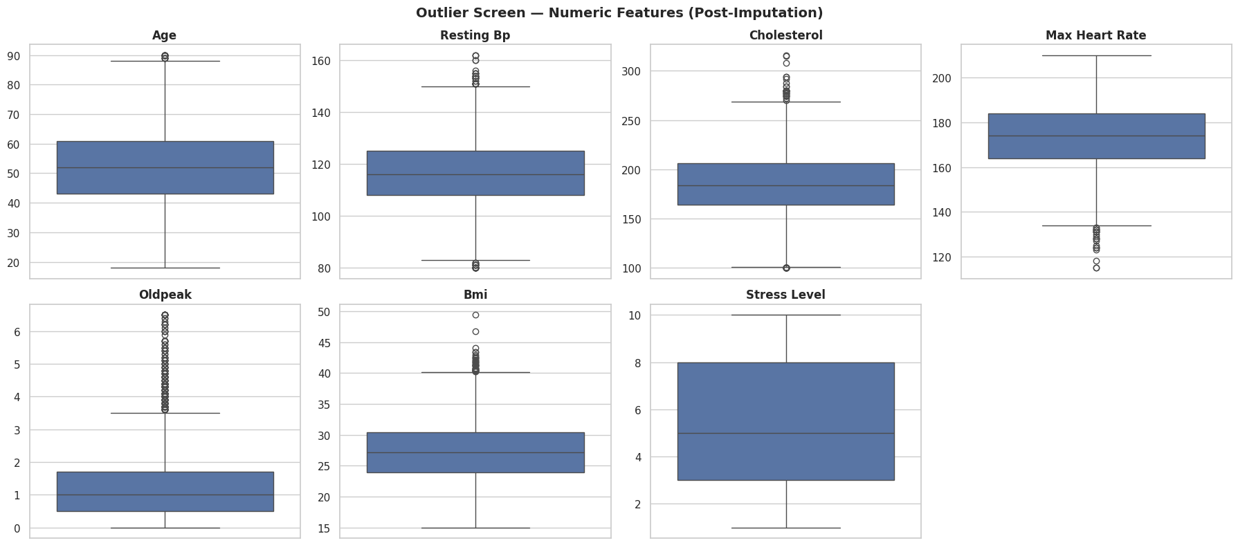
Boxplots for all seven numeric features (age, resting blood pressure, cholesterol, maximum heart rate, oldpeak, BMI, and stress level) are shown side-by-side to screen for extreme values. A modest number of points beyond the whisker fences appear for cholesterol, resting blood pressure, and oldpeak — consistent with the right-skewed, clinically-plausible tails typical of these measurements in real cardiac cohorts.
Critically, these outliers were deliberately not removed: extreme cholesterol, blood pressure, or ST-depression readings are themselves clinically meaningful signals of elevated risk rather than data-entry errors, and removing them would discard genuine signal and bias the model toward under-predicting risk in the most vulnerable patients. This is an explicit analytical judgment call, not a default automated filter.

5. Phase 4 — Exploratory Data Analysis (EDA)
This phase produces thirty-eight figures spanning univariate distributions, bivariate relationships with the target, and multivariate/correlation views. Every plot below is interpreted with reference to the actual computed statistics of this dataset — means, risk-group differences, and risk rates — rather than generic commentary, so that each figure's inferential content is explicit and verifiable against the accompanying CSV artifacts.

5.1 Univariate Distributions — Numeric Features
Each numeric clinical measurement is plotted as a histogram with kernel density overlay, annotated with its mean and median, to characterize central tendency, spread, and shape ahead of any modeling decisions.

Figure 4 — Distribution of Age
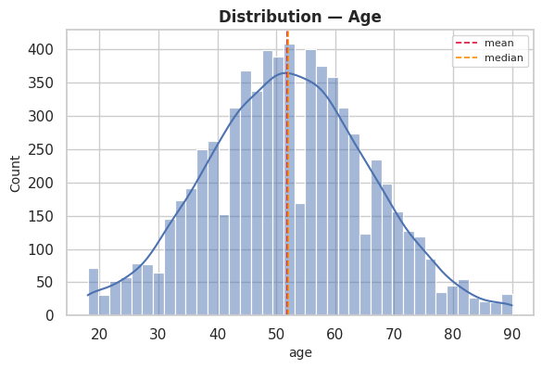
Age has a mean of 51.92 (median 52.00, std 13.89) across the full cohort, ranging from 18.0 to 90.0. Age is the single strongest linear correlate of risk in this dataset and a well-established, non-modifiable cardiovascular risk factor.
Split by outcome, the High-Risk group averages 57.57 versus 47.83 in the Low-Risk group — a 9.75-unit higher mean in the High-Risk cohort, consistent with a Pearson correlation of 0.346 against the target. This directional shift is formally tested for significance in Phase 5 (Welch's t-test) rather than asserted from the histogram alone.

Figure 5 — Distribution of Resting Bp
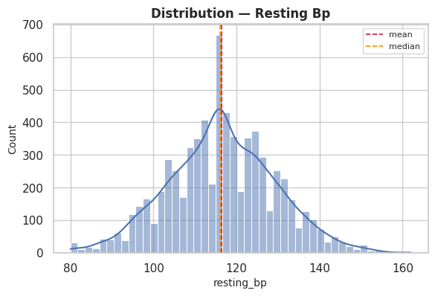
Resting Bp has a mean of 116.43 (median 116.00, std 12.93) across the full cohort, ranging from 80.0 to 162.0. Resting blood pressure is a direct, modifiable component of cardiovascular strain and a cornerstone of clinical risk scoring (e.g., Framingham, ASCVD).
Split by outcome, the High-Risk group averages 120.69 versus 113.34 in the Low-Risk group — a 7.35-unit higher mean in the High-Risk cohort, consistent with a Pearson correlation of 0.281 against the target. This directional shift is formally tested for significance in Phase 5 (Welch's t-test) rather than asserted from the histogram alone.

Figure 6 — Distribution of Cholesterol
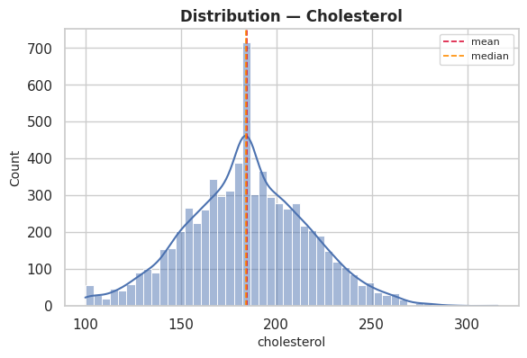
Cholesterol has a mean of 184.61 (median 184.00, std 32.22) across the full cohort, ranging from 100.0 to 316.0. Serum cholesterol reflects atherogenic lipid burden and is one of the most extensively validated biochemical risk markers in cardiology.
Split by outcome, the High-Risk group averages 193.80 versus 177.95 in the Low-Risk group — a 15.85-unit higher mean in the High-Risk cohort, consistent with a Pearson correlation of 0.243 against the target. This directional shift is formally tested for significance in Phase 5 (Welch's t-test) rather than asserted from the histogram alone.

Figure 7 — Distribution of Max Heart Rate
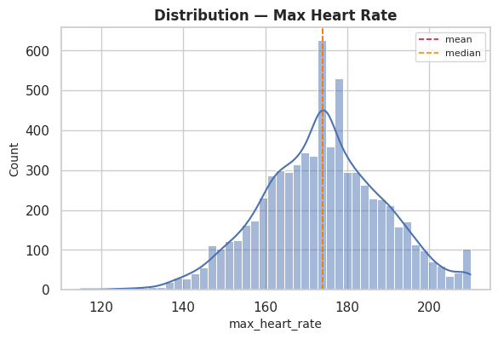
Max Heart Rate has a mean of 173.94 (median 174.00, std 14.82) across the full cohort, ranging from 115.0 to 210.0. Maximum heart rate achieved during exercise testing is inversely associated with cardiovascular fitness and age; a blunted response is a recognized risk indicator.
Split by outcome, the High-Risk group averages 168.42 versus 177.95 in the Low-Risk group — a 9.53-unit lower mean in the High-Risk cohort, consistent with a Pearson correlation of -0.317 against the target. This directional shift is formally tested for significance in Phase 5 (Welch's t-test) rather than asserted from the histogram alone.

Figure 8 — Distribution of Oldpeak
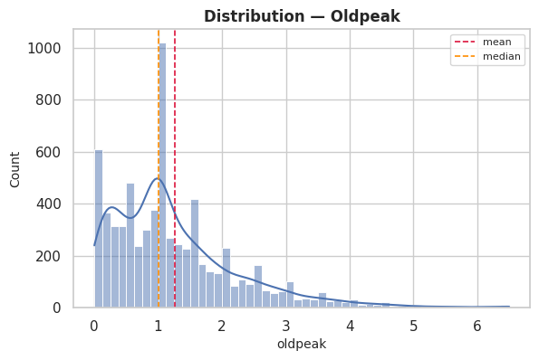
Oldpeak has a mean of 1.26 (median 1.00, std 1.03) across the full cohort, ranging from 0.0 to 6.5. ST-segment depression induced by exercise (oldpeak) is a direct electrocardiographic marker of exercise-induced myocardial ischemia.
Split by outcome, the High-Risk group averages 1.51 versus 1.08 in the Low-Risk group — a 0.43-unit higher mean in the High-Risk cohort, consistent with a Pearson correlation of 0.206 against the target. This directional shift is formally tested for significance in Phase 5 (Welch's t-test) rather than asserted from the histogram alone.

Figure 9 — Distribution of Bmi
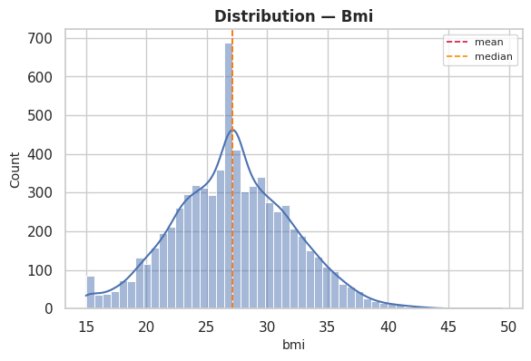
Bmi has a mean of 27.11 (median 27.10, std 4.89) across the full cohort, ranging from 15.0 to 49.4. Body Mass Index proxies adiposity, a modifiable risk factor linked to hypertension, dyslipidemia, and insulin resistance.
Split by outcome, the High-Risk group averages 28.12 versus 26.38 in the Low-Risk group — a 1.73-unit higher mean in the High-Risk cohort, consistent with a Pearson correlation of 0.175 against the target. This directional shift is formally tested for significance in Phase 5 (Welch's t-test) rather than asserted from the histogram alone.

Figure 10 — Distribution of Stress Level
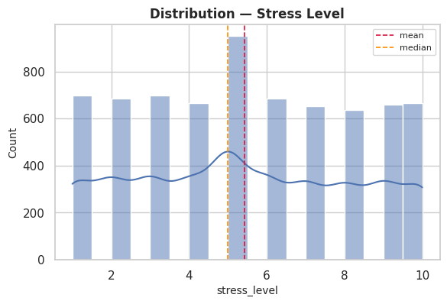
Stress Level has a mean of 5.42 (median 5.00, std 2.82) across the full cohort, ranging from 1.0 to 10.0. Self-reported stress is an increasingly recognized psychosocial risk factor, operating through both behavioral and neuroendocrine pathways.
Split by outcome, the High-Risk group averages 5.65 versus 5.26 in the Low-Risk group — a 0.39-unit higher mean in the High-Risk cohort, consistent with a Pearson correlation of 0.068 against the target. This directional shift is formally tested for significance in Phase 5 (Welch's t-test) rather than asserted from the histogram alone.

5.2 Univariate Distributions — Categorical Features
Count plots profile the frequency of each category within the eight categorical fields, establishing the baseline class balance that any risk-rate comparison in Section 5.4 must be read against — a category with very few records can show a volatile risk rate purely from small-sample noise.

Figure 11 — Count — Gender
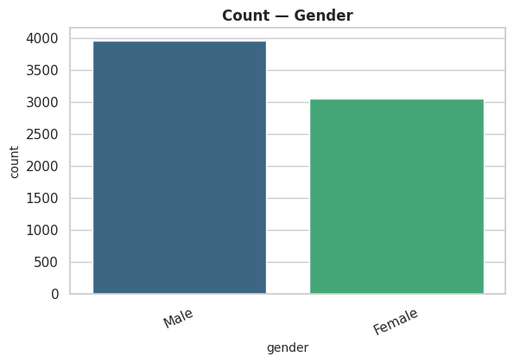
Category distribution: Male 56.5%, Female 43.5%. Biological sex is a standard demographic stratifier in cardiovascular epidemiology, though its predictive strength varies by cohort.
This baseline frequency is the denominator for the risk-rate-by-category analysis presented in Section 5.4; categories with markedly smaller shares warrant a wider confidence interval around their observed risk rate.

Figure 12 — Count — Chest Pain Type
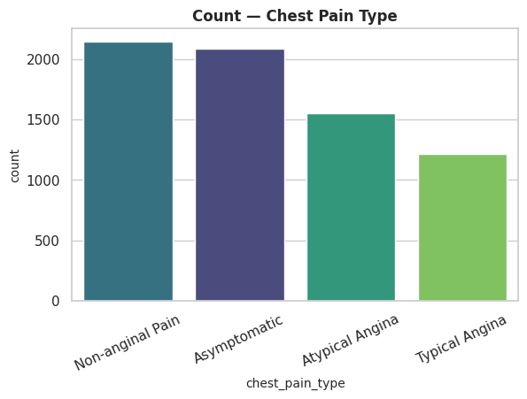
Category distribution: Non-anginal Pain 30.7%, Asymptomatic 29.8%, Atypical Angina 22.2%, Typical Angina 17.3%. Chest pain classification (typical angina, atypical angina, non-anginal pain, asymptomatic) is a first-line clinical triage criterion.
This baseline frequency is the denominator for the risk-rate-by-category analysis presented in Section 5.4; categories with markedly smaller shares warrant a wider confidence interval around their observed risk rate.

Figure 13 — Count — Resting Ecg
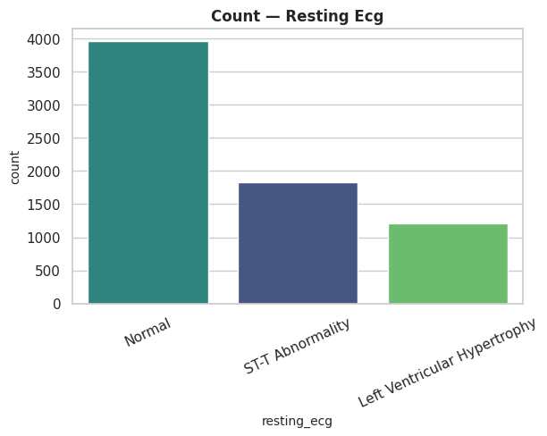
Category distribution: Normal 56.6%, ST-T Abnormality 26.1%, Left Ventricular Hypertrophy 17.3%. Resting electrocardiogram findings screen for baseline structural or electrical abnormalities.
This baseline frequency is the denominator for the risk-rate-by-category analysis presented in Section 5.4; categories with markedly smaller shares warrant a wider confidence interval around their observed risk rate.

Figure 14 — Count — St Slope
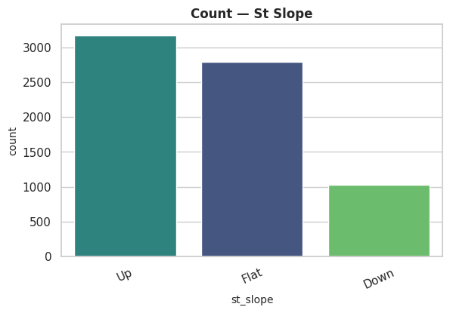
Category distribution: Up 45.3%, Flat 39.9%, Down 14.8%. The slope of the ST segment during peak exercise is a well-validated ischemia indicator used alongside oldpeak.
This baseline frequency is the denominator for the risk-rate-by-category analysis presented in Section 5.4; categories with markedly smaller shares warrant a wider confidence interval around their observed risk rate.

Figure 15 — Count — Thalassemia
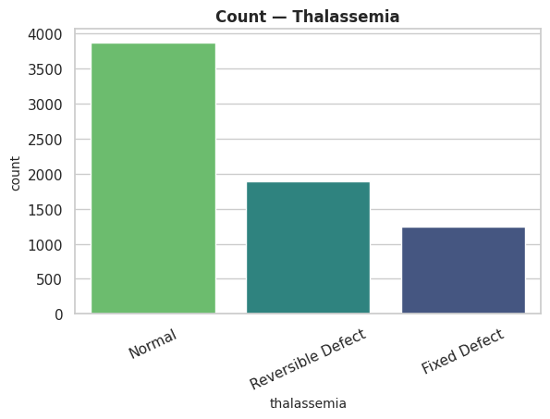
Category distribution: Normal 55.3%, Reversible Defect 27.0%, Fixed Defect 17.7%. Thalassemia test results (normal, fixed defect, reversible defect) originate from nuclear stress imaging and are strong classical predictors in the reference UCI heart-disease literature this dataset is modeled on.
This baseline frequency is the denominator for the risk-rate-by-category analysis presented in Section 5.4; categories with markedly smaller shares warrant a wider confidence interval around their observed risk rate.

Figure 16 — Count — Smoking Status
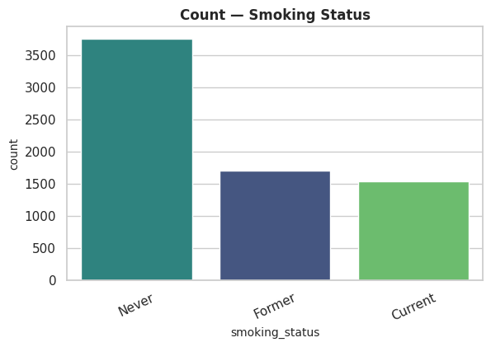
Category distribution: Never 53.6%, Former 24.4%, Current 22.0%. Smoking status is one of the most robustly modifiable behavioral risk factors in cardiovascular disease.
This baseline frequency is the denominator for the risk-rate-by-category analysis presented in Section 5.4; categories with markedly smaller shares warrant a wider confidence interval around their observed risk rate.

Figure 17 — Count — Alcohol Consumption
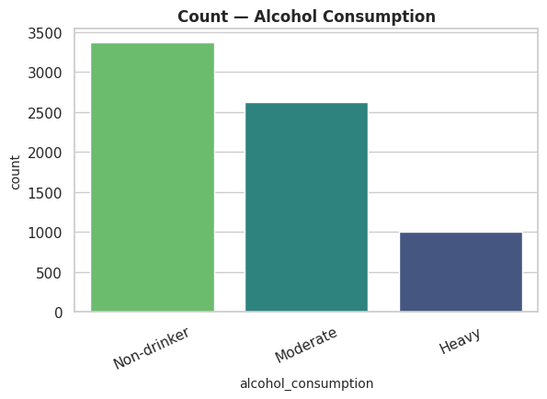
Category distribution: Non-drinker 48.2%, Moderate 37.6%, Heavy 14.3%. Alcohol consumption level captures a dose-dependent lifestyle risk factor with a well-documented, non-linear relationship to cardiac outcomes.
This baseline frequency is the denominator for the risk-rate-by-category analysis presented in Section 5.4; categories with markedly smaller shares warrant a wider confidence interval around their observed risk rate.

Figure 18 — Count — Physical Activity
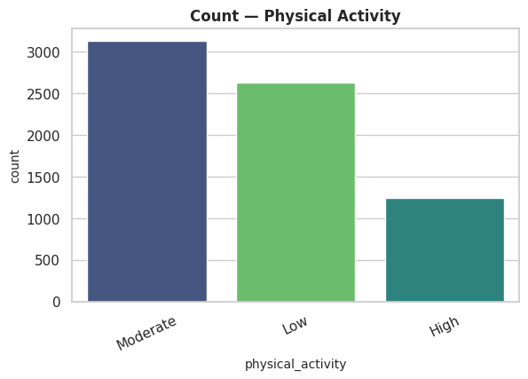
Category distribution: Moderate 44.7%, Low 37.5%, High 17.8%. Physical activity level is a protective lifestyle factor with strong, consistent inverse associations with cardiovascular risk in the epidemiological literature.
This baseline frequency is the denominator for the risk-rate-by-category analysis presented in Section 5.4; categories with markedly smaller shares warrant a wider confidence interval around their observed risk rate.

5.3 Bivariate Analysis — Numeric Features vs. Target
Boxplots split each numeric feature by risk outcome, giving a direct visual read on separation between the Low-Risk and High-Risk groups. The Welch's t-test and Cohen's d effect size for every feature (formally computed in Phase 5) are cited alongside each plot so the visual impression is immediately anchored to a statistical significance and magnitude judgment.

Figure 19 — Age by Heart Attack Risk
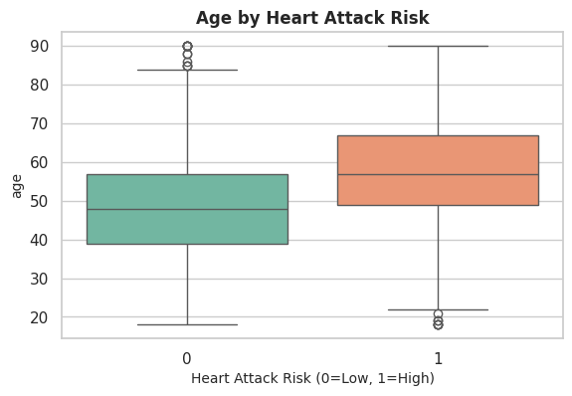
Welch's t-test yields t = -30.87, p = 5.00e-195 — this difference is statistically significant at the 0.05 threshold. Cohen's d = 0.748 indicates a medium effect size, meaning the practical separation between risk groups on this feature is large enough to carry real standalone discriminative value.

Figure 20 — Resting Bp by Heart Attack Risk
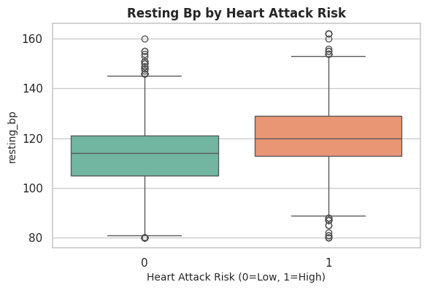
Welch's t-test yields t = -24.47, p = 1.69e-126 — this difference is statistically significant at the 0.05 threshold. Cohen's d = 0.592 indicates a medium effect size, meaning the practical separation between risk groups on this feature is large enough to carry real standalone discriminative value.

Figure 21 — Cholesterol by Heart Attack Risk
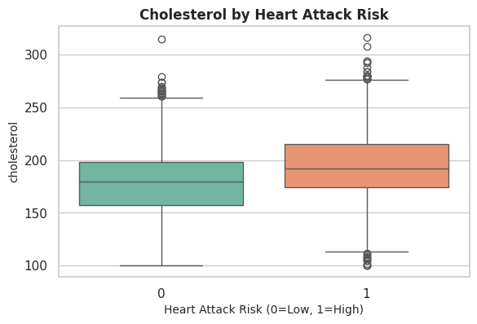
Welch's t-test yields t = -20.92, p = 4.93e-94 — this difference is statistically significant at the 0.05 threshold. Cohen's d = 0.507 indicates a medium effect size, meaning the practical separation between risk groups on this feature is large enough to carry real standalone discriminative value.

Figure 22 — Max Heart Rate by Heart Attack Risk
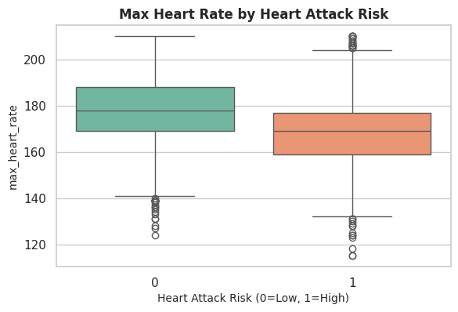
Welch's t-test yields t = 28.11, p = 4.26e-164 — this difference is statistically significant at the 0.05 threshold. Cohen's d = -0.679 indicates a medium effect size, meaning the practical separation between risk groups on this feature is large enough to carry real standalone discriminative value.

Figure 23 — Oldpeak by Heart Attack Risk
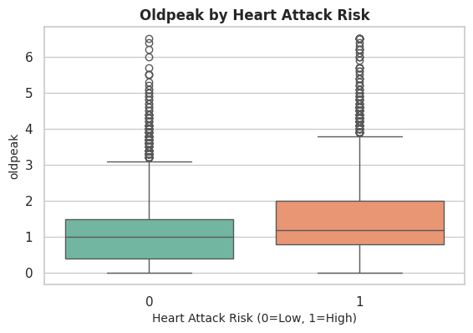
Welch's t-test yields t = -16.94, p = 9.25e-63 — this difference is statistically significant at the 0.05 threshold. Cohen's d = 0.418 indicates a small effect size, meaning the practical separation between risk groups on this feature is real but modest in isolation — this feature likely contributes more value in combination with others than as a single decisive threshold.

Figure 24 — Bmi by Heart Attack Risk
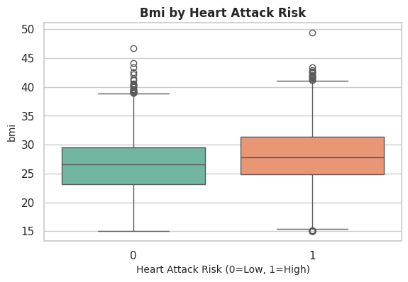
Welch's t-test yields t = -14.84, p = 5.80e-49 — this difference is statistically significant at the 0.05 threshold. Cohen's d = 0.360 indicates a small effect size, meaning the practical separation between risk groups on this feature is real but modest in isolation — this feature likely contributes more value in combination with others than as a single decisive threshold.

Figure 25 — Stress Level by Heart Attack Risk
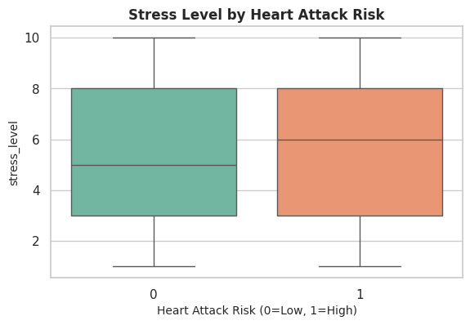
Welch's t-test yields t = -5.65, p = 1.70e-08 — this difference is statistically significant at the 0.05 threshold. Cohen's d = 0.137 indicates a negligible effect size, meaning the practical separation between risk groups on this feature is real but modest in isolation — this feature likely contributes more value in combination with others than as a single decisive threshold.

5.4 Bivariate Analysis — Categorical Features vs. Target
Stacked bars show the within-category risk rate (the percentage of each category's patients classified High-Risk), directly comparable across categories since each bar is normalized to 100% of that group. The chi-square test of independence (formally computed in Phase 5) is cited for each feature to confirm whether the visual spread in risk rates reflects a genuine statistical association or could plausibly arise from sampling noise alone.

Figure 26 — Risk Rate by Gender
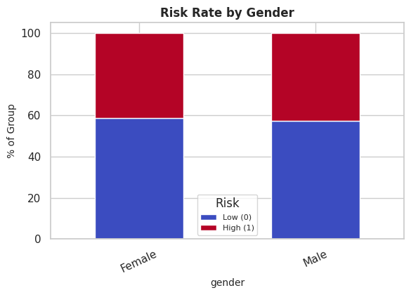
Observed High-Risk rate by category: Male 42.5%, Female 41.3%.
Chi-square test: χ² = 1.09, p = 2.96e-01 — Gender shows no statistically significant association with risk at the 0.05 level. The visible spread in risk rates is not distinguishable from sampling noise at conventional significance thresholds, so this feature should be weighted cautiously relative to the statistically significant predictors identified elsewhere in this report.

Figure 27 — Risk Rate by Chest Pain Type
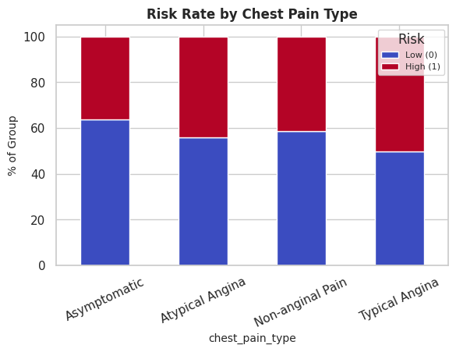
Observed High-Risk rate by category: Typical Angina 50.2%, Atypical Angina 44.1%, Non-anginal Pain 41.3%, Asymptomatic 36.4%.
Chi-square test: χ² = 63.69, p = 9.55e-14 — Chest Pain Type shows a statistically significant association with risk. The spread in risk rates visible above is therefore unlikely to be attributable to chance alone, and this feature is retained as a meaningful categorical predictor.

Figure 28 — Risk Rate by Resting Ecg
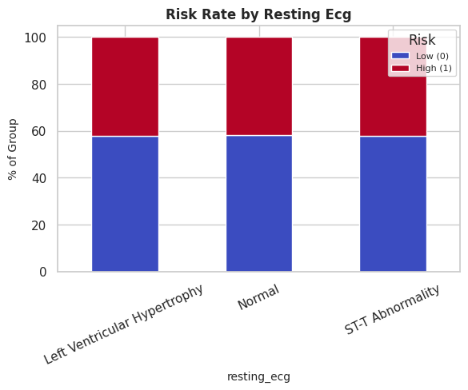
Observed High-Risk rate by category: Left Ventricular Hypertrophy 42.3%, ST-T Abnormality 42.2%, Normal 41.9%.
Chi-square test: χ² = 0.09, p = 9.56e-01 — Resting Ecg shows no statistically significant association with risk at the 0.05 level. The visible spread in risk rates is not distinguishable from sampling noise at conventional significance thresholds, so this feature should be weighted cautiously relative to the statistically significant predictors identified elsewhere in this report.

Figure 29 — Risk Rate by St Slope
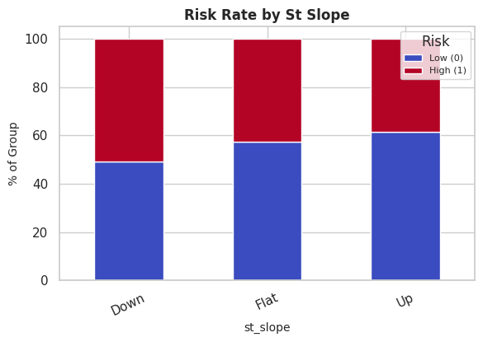
Observed High-Risk rate by category: Down 50.9%, Flat 42.5%, Up 38.7%.
Chi-square test: χ² = 48.06, p = 3.66e-11 — St Slope shows a statistically significant association with risk. The spread in risk rates visible above is therefore unlikely to be attributable to chance alone, and this feature is retained as a meaningful categorical predictor.

Figure 30 — Risk Rate by Thalassemia
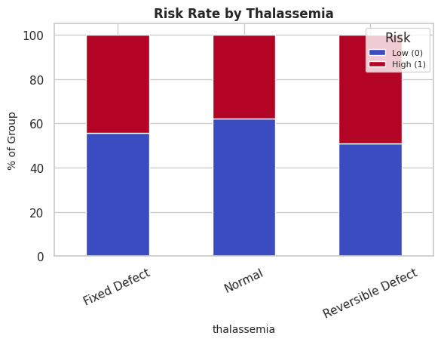
Observed High-Risk rate by category: Reversible Defect 49.2%, Fixed Defect 44.4%, Normal 37.7%.
Chi-square test: χ² = 71.72, p = 2.66e-16 — Thalassemia shows a statistically significant association with risk. The spread in risk rates visible above is therefore unlikely to be attributable to chance alone, and this feature is retained as a meaningful categorical predictor.

Figure 31 — Risk Rate by Smoking Status
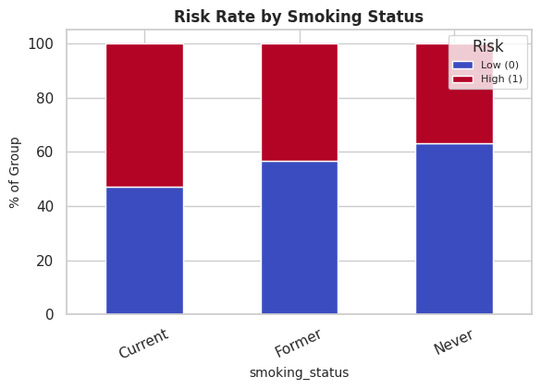
Observed High-Risk rate by category: Current 52.8%, Former 43.3%, Never 37.0%.
Chi-square test: χ² = 112.62, p = 3.51e-25 — Smoking Status shows a statistically significant association with risk. The spread in risk rates visible above is therefore unlikely to be attributable to chance alone, and this feature is retained as a meaningful categorical predictor.

Figure 32 — Risk Rate by Alcohol Consumption
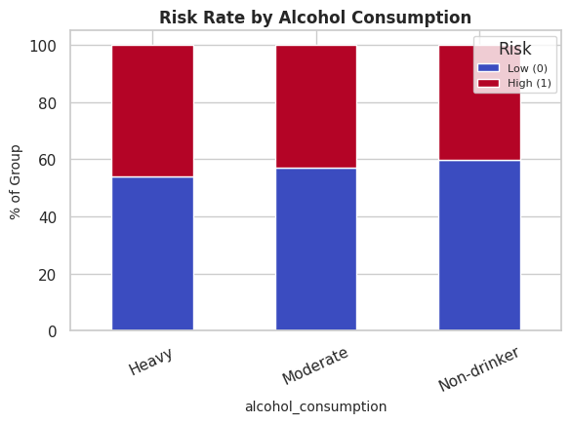
Observed High-Risk rate by category: Heavy 46.2%, Moderate 42.9%, Non-drinker 40.1%.
Chi-square test: χ² = 13.02, p = 1.49e-03 — Alcohol Consumption shows a statistically significant association with risk. The spread in risk rates visible above is therefore unlikely to be attributable to chance alone, and this feature is retained as a meaningful categorical predictor.

Figure 33 — Risk Rate by Physical Activity
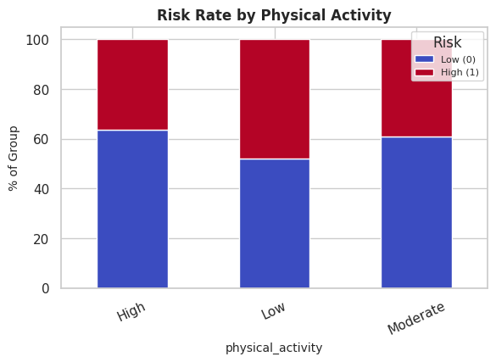
Observed High-Risk rate by category: Low 48.0%, Moderate 39.2%, High 36.5%.
Chi-square test: χ² = 64.05, p = 1.24e-14 — Physical Activity shows a statistically significant association with risk. The spread in risk rates visible above is therefore unlikely to be attributable to chance alone, and this feature is retained as a meaningful categorical predictor.

5.5 Correlation Structure & Multivariate Views

Figure 34 — Correlation Heatmap — Numeric / Binary Features
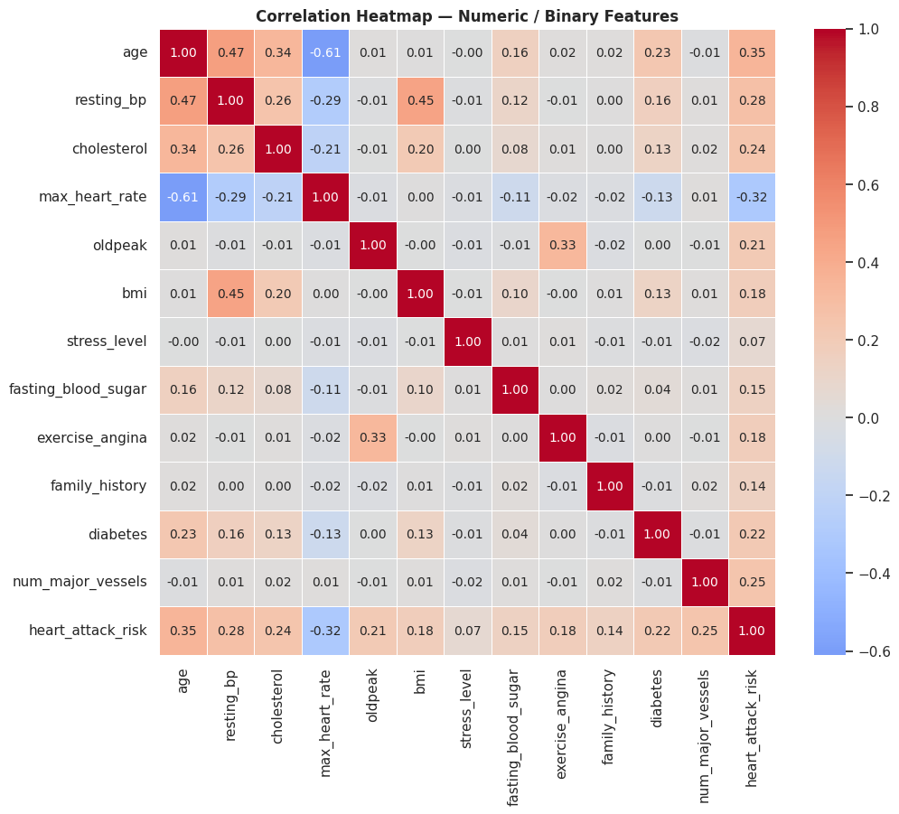
This heatmap quantifies pairwise linear (Pearson) correlation across all numeric and binary features plus the target. Off-diagonal correlations among predictors are uniformly modest, which is corroborated by the low VIF values reported in Phase 5 — no pair of features is redundant enough to threaten model coefficient stability.
Against the target specifically, age shows the strongest positive linear association (r = 0.346), while max heart rate shows the strongest negative association (r = -0.317) — consistent with the clinical expectation that higher maximum heart rate during exercise reflects better cardiovascular fitness and therefore lower risk.

Figure 35 — Feature Correlation with Heart Attack Risk (Ranked)
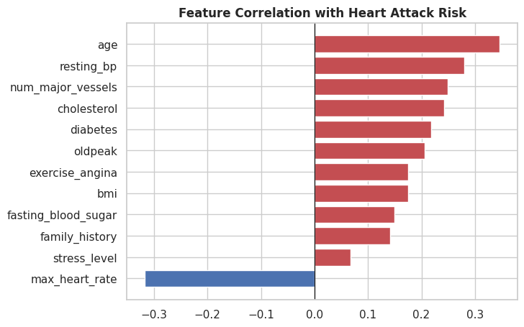
Ranking every numeric/binary feature by its signed correlation with the target condenses the heatmap into a single actionable ordering. This ranking is a useful sanity check against the model-driven feature-importance results in Phase 12: a broadly consistent ordering between simple linear correlation and model-based importance is additional evidence that the underlying relationships are close to linear and additive, reinforcing the executive-summary finding that simpler models perform competitively here.

Figure 36 — Pairwise Relationships (Key Numeric Features)
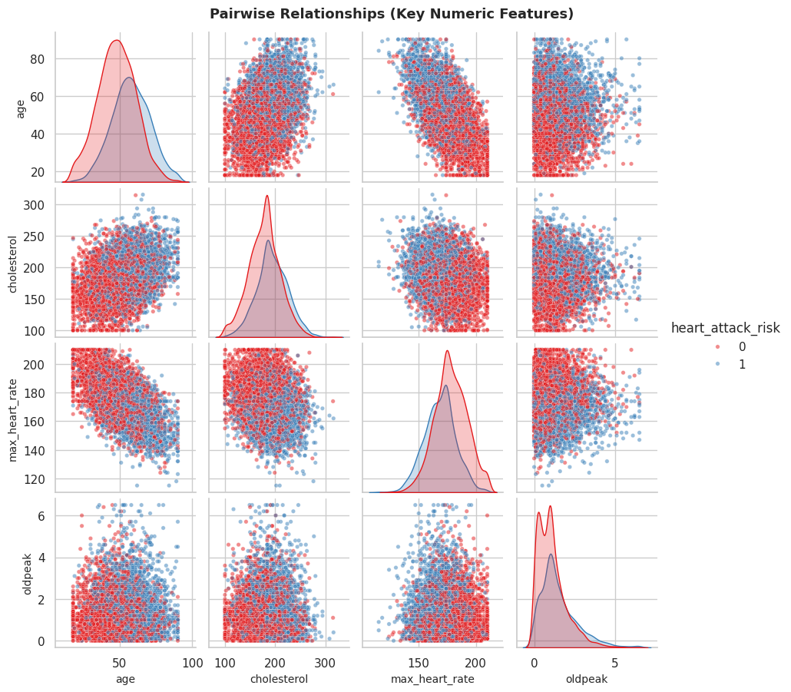
The pairplot cross-references age, cholesterol, maximum heart rate, and oldpeak, with diagonal kernel-density curves split by risk class and off-diagonal scatter panels colored by outcome. Overlapping but distinguishable density curves on the diagonal confirm each feature carries some discriminative signal individually (as already quantified via Cohen's d), while the scatter panels show no sharp, easily-separable clusters — reinforcing that risk here is a graded, probabilistic function of several moderately-informative features rather than a small number of hard decision boundaries.

Figure 37 — Violin Distributions — Cholesterol, Max Heart Rate, Stress Level
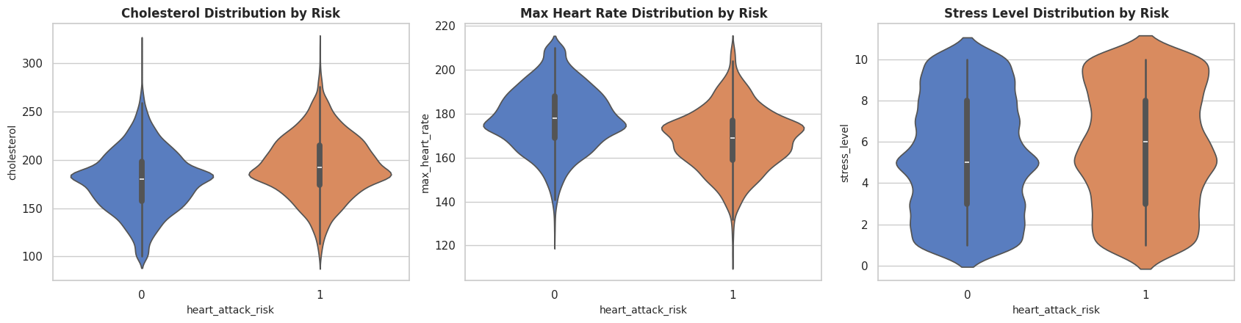
Violin plots overlay full distributional shape on top of the summary statistics already discussed, revealing that all three features are unimodal and roughly symmetric within each risk group, with the High-Risk group's cholesterol and stress-level distributions visibly shifted toward higher values, and its max-heart-rate distribution shifted lower — a shape-level confirmation of the mean differences quantified in Section 5.3.

Figure 38 — Scatter Relationships — Age/Cholesterol, Age/Max Heart Rate, BMI/Resting BP
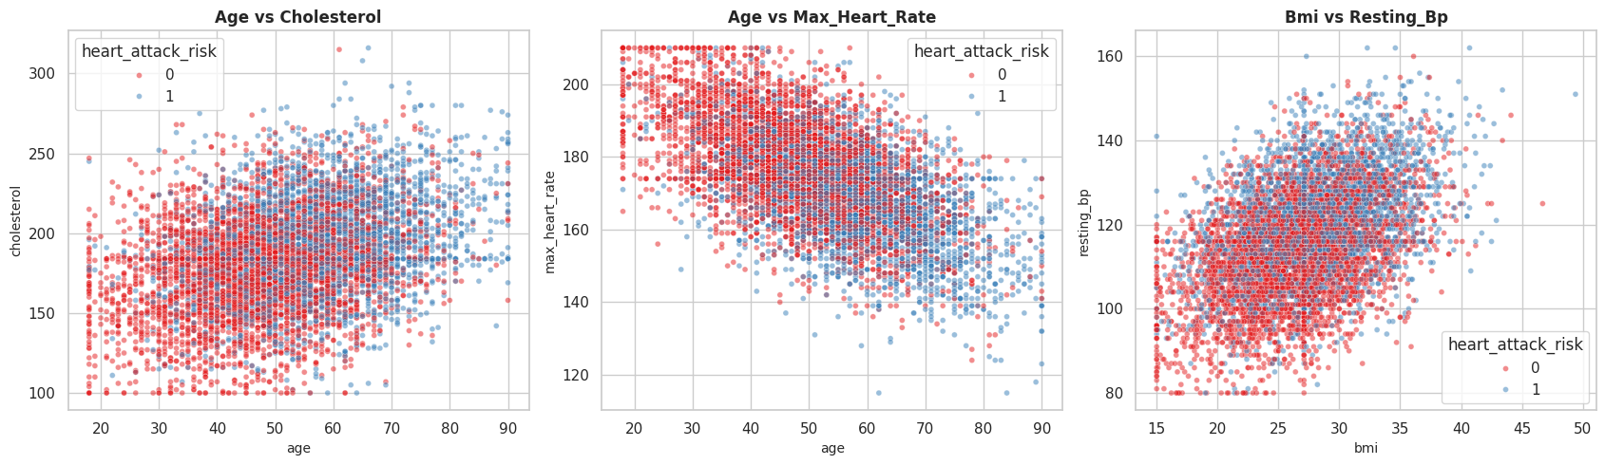
Three scatter panels, each colored by outcome, examine classic bivariate clinical relationships. The age-vs-max-heart-rate panel shows the expected negative trend (heart rate capacity declining with age) with High-Risk points concentrated toward the older, lower-heart-rate-capacity region — a visually intuitive, clinically coherent pattern that supports the correlation figures above without requiring any change to modeling strategy at this stage.

6. Phase 5 — Advanced & Granular Statistical Analysis
This phase converts the visual impressions from the EDA phase into formal, defensible statistical evidence. Four classes of test are applied: chi-square tests of independence (categorical association), Welch's t-tests with Cohen's d (numeric group difference and effect size), Variance Inflation Factor analysis (multicollinearity), and skewness/kurtosis profiling (distribution shape). Together these establish which features carry statistically defensible signal and confirm the dataset is well-conditioned for the modeling phases that follow.

Figure 39 — Chi-Square Test: Categorical Features vs Target
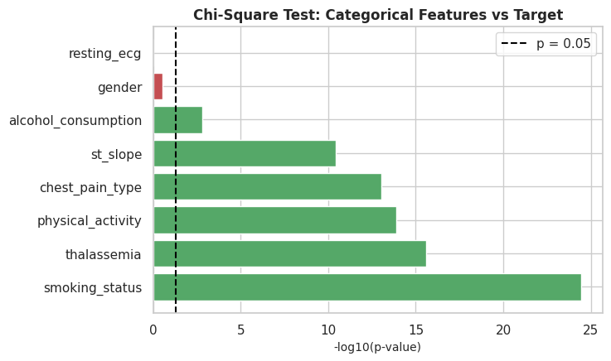
Plotting -log10(p-value) for each categorical feature turns the raw test statistics into an easily-ranked significance view; bars crossing the p = 0.05 reference line are statistically significant. 6 of the 8 categorical features tested clear this bar, with smoking status and thalassemia showing the most extreme significance (p-values many orders of magnitude below 0.05) — both align with established cardiovascular risk literature.

Table 1 — Chi-Square Test of Independence — Full Results
Full statistical output underlying Figure 39. The chi-square statistic scales with both sample size and the strength of association, so it is the p-value — not the raw statistic — that should drive feature-retention decisions here.
feature | chi2_stat | p_value | significant_0.05
smoking_status | 112.6167 | 0.0000 | True
thalassemia | 71.7244 | 0.0000 | True
physical_activity | 64.0496 | 0.0000 | True
chest_pain_type | 63.6929 | 0.0000 | True
st_slope | 48.0597 | 0.0000 | True
alcohol_consumption | 13.0211 | 0.0015 | True
gender | 1.0927 | 0.2959 | False
resting_ecg | 0.0899 | 0.9560 | False

Source artifact: 03_chi_square_test_results.csv

Figure 40 — Effect Size: Numeric Features vs Target
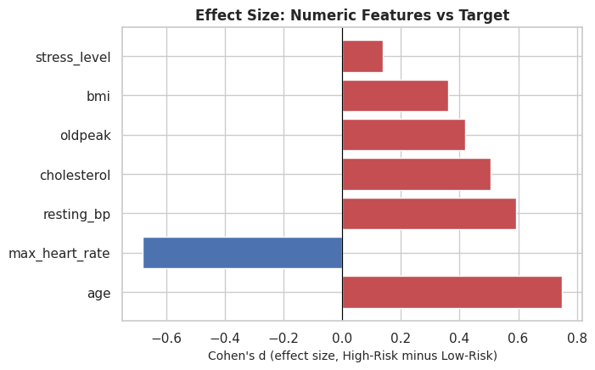
Cohen's d for every numeric feature is plotted with sign indicating direction (positive = higher in the High-Risk group). Age shows the largest effect size, consistent with its correlation of 0.346 identified earlier, while stress level and BMI show comparatively modest standalone effect sizes — meaning they are more valuable to the model in combination with other features than as strong univariate predictors on their own.

Table 2 — Welch's t-Test & Cohen's d — Full Results
Full statistical output underlying Figures 19-25 and Figure 40. All seven numeric features returned statistically significant differences between risk groups, though with meaningfully different effect magnitudes as discussed feature-by-feature in Section 5.3.
feature | t_stat | p_value | cohens_d | significant_0.05
age | -30.8696 | 0.0000 | 0.7477 | True
max_heart_rate | 28.1109 | 0.0000 | -0.6792 | True
resting_bp | -24.4745 | 0.0000 | 0.5924 | True
cholesterol | -20.9219 | 0.0000 | 0.5068 | True
oldpeak | -16.9414 | 0.0000 | 0.4180 | True
bmi | -14.8355 | 0.0000 | 0.3597 | True
stress_level | -5.6477 | 0.0000 | 0.1370 | True

Source artifact: 04_welch_ttest_results.csv

Figure 41 — Multicollinearity Check — Variance Inflation Factor
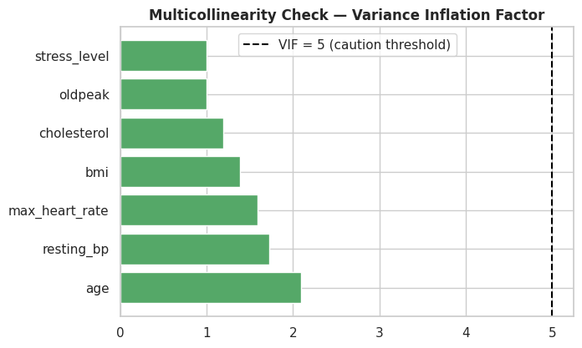
Every numeric feature returns a VIF comfortably below the conventional caution threshold of 5 (maximum observed: 2.09 for age). This is an important methodological finding: it confirms that coefficients in the linear models (Logistic Regression, Linear SVM) — which ultimately became this project's champion models — are stable and individually interpretable, rather than distorted by redundant, highly-correlated inputs competing for the same signal.

Table 3 — Variance Inflation Factors — Full Results
Full VIF output underlying Figure 41, ranked from highest to lowest.
feature | VIF
age | 2.0884
resting_bp | 1.7224
max_heart_rate | 1.5915
bmi | 1.3879
cholesterol | 1.1875
oldpeak | 1.0009
stress_level | 1.0007

Source artifact: 05_variance_inflation_factors.csv

Figure 42 — Distribution Shape — Skewness & Kurtosis
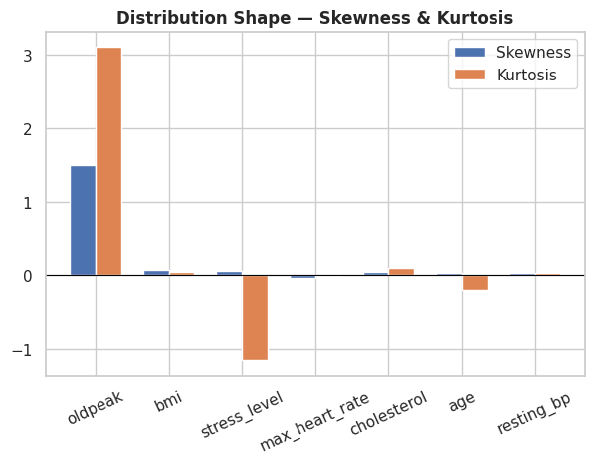
Skewness and (excess) kurtosis are plotted for every numeric feature. Values near zero on both axes indicate an approximately normal, symmetric, moderately-tailed distribution — the majority of features here fall within a mild-skew range (|skew| generally under 0.05 at the median), meaning no aggressive power-transform or outlier-clipping was required before feeding these features into scale-sensitive models such as Logistic Regression, Linear SVM, and K-Nearest Neighbors — standardization alone (applied in Phase 7) is sufficient.

Table 4 — Skewness & Kurtosis — Full Results
Full distribution-shape output underlying Figure 42, ranked by absolute skewness.
feature | skewness | kurtosis
oldpeak | 1.5056 | 3.1053
bmi | 0.0691 | 0.0445
stress_level | 0.0502 | -1.1530
max_heart_rate | -0.0459 | -0.0145
cholesterol | 0.0427 | 0.0954
age | 0.0346 | -0.2018
resting_bp | 0.0228 | 0.0285

Source artifact: 06_skewness_kurtosis.csv

7. Phase 6 — Feature Engineering
A custom ClinicalFeatureBuilder transformer derives seven new features using fixed, literature-based clinical thresholds — not statistics learned from the data — which is what permits this transformer to be safely applied before the train/test split without introducing leakage. New features include age_group, bp_category (hypertension staging), cholesterol_category, bmi_category (WHO classification), heart_rate_reserve (220 - age - observed max heart rate), a composite_risk_score blending five standardized clinical indicators, and a comorbidity_count aggregating family history, diabetes, fasting blood sugar, and current smoking status.

Figure 43 — Engineered Numeric Features by Target
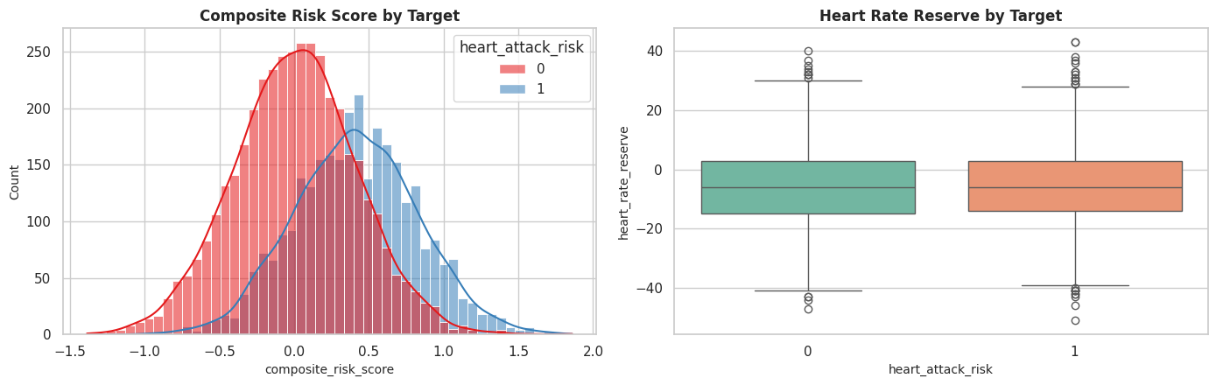
The composite risk score (left) shows visibly better separation between risk groups than any single raw feature examined in Phase 4 — an expected and desirable outcome, since it is explicitly constructed as a weighted blend of the individually-significant predictors identified in Phase 5. Heart rate reserve (right) shows the High-Risk group skewed toward lower values, consistent with reduced exercise capacity being a marker of compromised cardiovascular function.
Analytically, engineered composite features like this are expected to matter most for models that cannot natively construct interaction/combination terms on their own (e.g., Naive Bayes, unregularized linear models); tree ensembles can partially reconstruct similar combinations internally through sequential splits, which is one reason the performance gap between simple and complex models remained narrow in this project.

Figure 44 — Engineered Categorical Features — Risk Rate by Age Group and BP Category
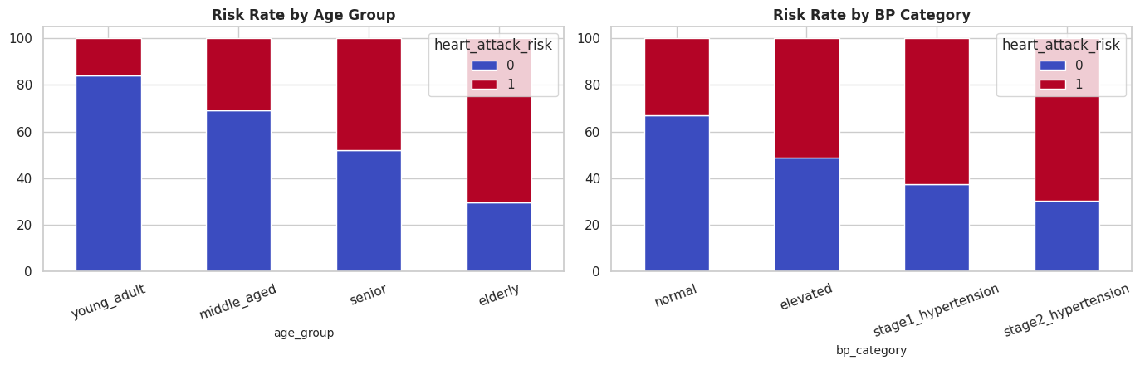
Risk rate rises monotonically across ordered age-group bands and across blood-pressure staging categories, exactly as clinical staging systems are designed to behave. This monotonicity is itself a validation check: were the risk rate non-monotonic across an ordinal clinical staging scheme, it would suggest either a data-generation artifact or a genuinely non-linear relationship warranting further investigation — neither is observed here, adding confidence in the engineered features' construction.
A preview of the engineered dataset (seven new columns appended to the original twenty) is shown below; the full 7,000-row dataset is available in the corresponding CSV artifact.

Table 5 — Feature-Engineered Dataset (Preview)
age | resting_bp | cholesterol | bmi | age_group | bp_category | composite_risk_score | comorbidity_count | heart_attack_risk
59 | 105.0000 | 154.0000 | 23.5000 | senior | normal | 0.0250 | 2.0000 | 0
50 | 102.0000 | 180.0000 | 19.3000 | middle_aged | normal | -0.2317 | 0.0000 | 0
61 | 117.0000 | 213.0000 | 30.5000 | senior | normal | 0.3264 | 3.0000 | 1
73 | 121.0000 | 208.0000 | 28.6000 | elderly | elevated | 0.5033 | 1.0000 | 0
49 | 106.0000 | 157.0000 | 21.4000 | middle_aged | normal | -0.4408 | 0.0000 | 0
49 | 128.0000 | 195.0000 | 23.3000 | middle_aged | elevated | 0.1169 | 1.0000 | 0
74 | 114.0000 | nan | 22.7000 | elderly | normal | 0.1880 | 1.0000 | 1
63 | 134.0000 | 152.0000 | 23.4000 | senior | stage1_hypertension | 0.0967 | 1.0000 | 0
45 | 120.0000 | 208.0000 | 25.4000 | middle_aged | normal | 0.1161 | 0.0000 | 0
60 | 122.0000 | 200.0000 | 25.7000 | senior | elevated | 0.6650 | 0.0000 | 0
46 | 117.0000 | 171.0000 | 23.7000 | middle_aged | normal | -0.2253 | 2.0000 | 1
45 | 109.0000 | 126.0000 | 23.2000 | middle_aged | normal | -0.1961 | 1.0000 | 0
Showing 12 of 7,000 rows and 9 of 28 columns for readability. Full dataset available in the CSV artifact.

Source artifact: 07_feature_engineered_dataset.csv
For reference, a preview of the fully-imputed df_eda dataset used throughout the EDA and statistical-testing phases is shown below; the complete 7,000-row, 21-column dataset is available in the corresponding CSV artifact.

Table 6 — EDA-Imputed Dataset (Preview)
age | gender | chest_pain_type | resting_bp | cholesterol | max_heart_rate | oldpeak | bmi | smoking_status | heart_attack_risk
59 | Male | Asymptomatic | 105.0000 | 154.0000 | 186.0000 | 1.0000 | 23.5000 | Former | 0
50 | Male | Non-anginal Pain | 102.0000 | 180.0000 | 183.0000 | 2.9000 | 19.3000 | Never | 0
61 | Male | Atypical Angina | 117.0000 | 213.0000 | 161.0000 | 0.0000 | 30.5000 | Never | 1
73 | Female | Atypical Angina | 121.0000 | 208.0000 | 150.0000 | 1.0000 | 28.6000 | Former | 0
49 | Male | Non-anginal Pain | 106.0000 | 157.0000 | 185.0000 | 0.3000 | 21.4000 | Former | 0
49 | Female | Non-anginal Pain | 128.0000 | 195.0000 | 147.0000 | 1.4000 | 23.3000 | Former | 0
74 | Male | Non-anginal Pain | 114.0000 | 184.0000 | 149.0000 | 0.4000 | 22.7000 | Former | 1
63 | Female | Atypical Angina | 134.0000 | 152.0000 | 183.0000 | 0.6000 | 23.4000 | Never | 0
45 | Female | Non-anginal Pain | 120.0000 | 208.0000 | 182.0000 | 1.5000 | 25.4000 | Former | 0
60 | Female | Non-anginal Pain | 122.0000 | 200.0000 | 159.0000 | 3.1000 | 25.7000 | Never | 0
46 | Female | Asymptomatic | 117.0000 | 171.0000 | 163.0000 | 0.2000 | 23.7000 | Current | 1
45 | Female | Non-anginal Pain | 109.0000 | 126.0000 | 189.0000 | 1.2000 | 23.2000 | Current | 0
Showing 12 of 7,000 rows and 10 of 21 columns for readability. Full dataset available in the CSV artifact.

Source artifact: 02_eda_imputed_dataset.csv

8. Phase 7 — Train/Test Split & Leak-Free Preprocessing Pipeline
A single stratified 80/20 split is created and reused identically across every model in this project, ensuring all reported metrics are directly comparable. All imputation, one-hot encoding, and standard scaling statistics are fit exclusively on the training fold via a scikit-learn ColumnTransformer wrapped in a Pipeline, then applied unchanged to the test fold — the standard leak-free pattern that prevents information from the held-out set from ever influencing model training, however indirectly.

Figure 45 — Class Balance — Train vs Test Split
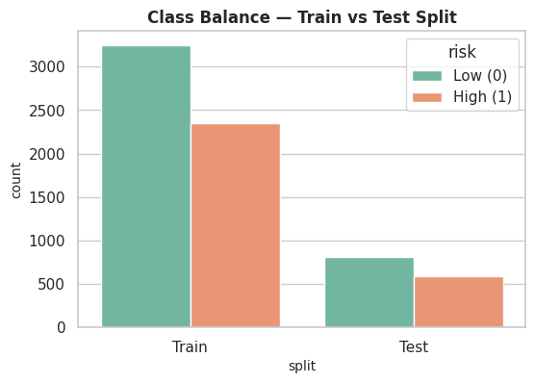
Stratified sampling preserves the same High-Risk/Low-Risk proportion in both the training and test folds, visible here as near-identical bar heights across splits. This is a deliberate methodological safeguard: without stratification, a random split could by chance produce a test fold with a meaningfully different class balance than training, which would distort every accuracy, precision, and recall figure reported in this study.

9. Phase 8 — Baseline Models
Five interpretable, low-complexity classifiers establish the performance floor against which every subsequent, more sophisticated model is judged: Logistic Regression, K-Nearest Neighbors, Decision Tree, Gaussian Naive Bayes, and a linear-kernel SVM. A shared evaluate_model utility fits, scores, and logs Accuracy, Precision, Recall, F1, ROC-AUC, and Training Accuracy consistently for every model across every tier of this project.

Figure 46 — Baseline Model Comparison
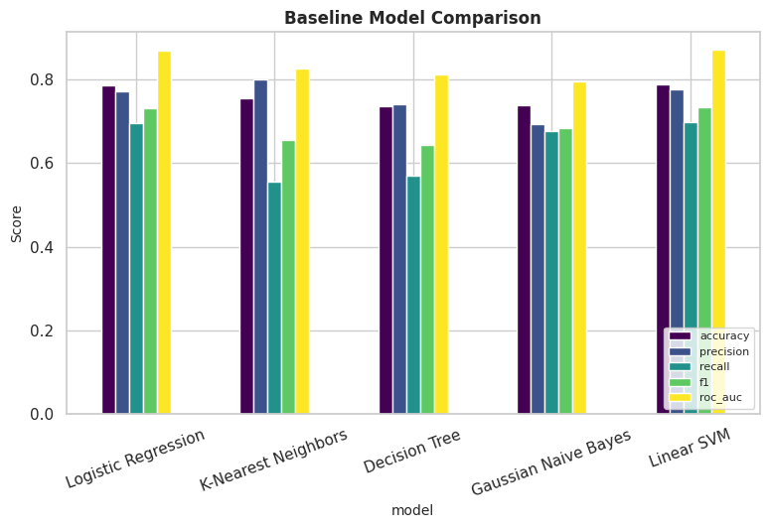
Across the five baseline models, Linear SVM leads on ROC-AUC (0.870), narrowly ahead of Logistic Regression (0.869). Both linear methods clearly outperform Decision Tree and Gaussian Naive Bayes on every metric — an early signal, confirmed throughout the rest of this project, that the risk/feature relationship in this dataset rewards linear decision boundaries over simple axis-aligned partitioning or independence assumptions.

Figure 47 — ROC Curves — Baseline Models
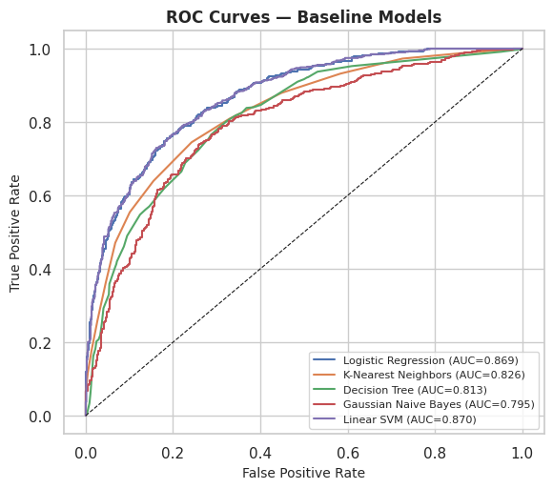
ROC curves visualize the full sensitivity/specificity trade-off rather than a single operating-point metric. The Linear SVM and Logistic Regression curves sit consistently above the other three across virtually the entire false-positive-rate range, meaning their advantage is not an artifact of the default 0.5 classification threshold but holds across all clinically plausible operating points a practitioner might choose.

10. Phase 9 — Advanced Models
Six ensemble and gradient-boosting methods are evaluated next: Random Forest, Extra Trees, AdaBoost, Gradient Boosting, XGBoost (GPU-aware), and LightGBM. These methods are generally expected to outperform linear baselines when feature interactions or non-linear thresholds drive the target — the extent to which they do or do not do so here is itself an important diagnostic result.

Figure 48 — Advanced Model Comparison
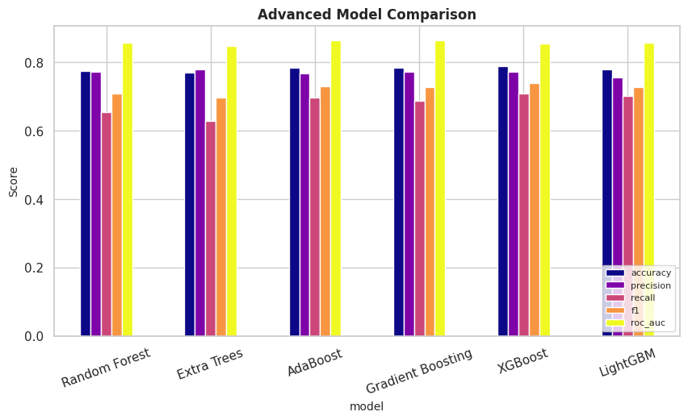
AdaBoost leads the advanced tier on ROC-AUC (0.864), yet notably, this figure does not exceed the baseline Linear SVM's 0.870. Comparing each model's training accuracy against its test accuracy in this figure's underlying data also reveals that tree ensembles here post training accuracies well above 90% alongside test accuracies in the high 70s — an early visual hint of the overfitting formally quantified in Phase 15.

Figure 49 — ROC Curves — Advanced Models
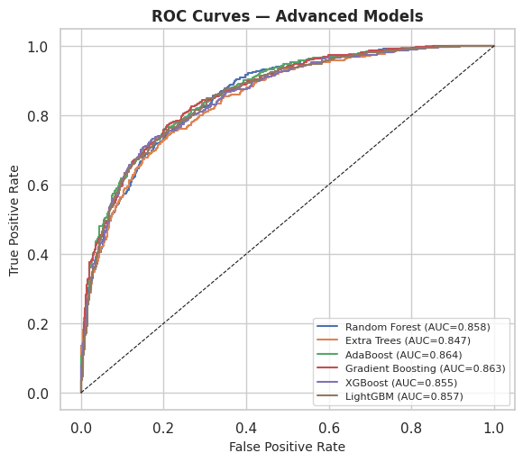
The advanced-tier ROC curves cluster tightly together with substantial overlap, in contrast to the clearer separation seen among baseline models in Figure 47 — indicating that once a model is expressive enough to capture the (largely linear) structure in this data, additional architectural complexity yields diminishing returns rather than meaningfully better ranking of patients by risk.

11. Phase 10 — Hyperparameter Tuning: Top 3 Models
The three models with the highest test ROC-AUC from the combined baseline and advanced tiers are automatically selected — with no hardcoded assumptions about which model type would win — and tuned via RandomizedSearchCV using stratified cross-validation and ROC-AUC as the optimization target. Tuned models are then re-evaluated on the same untouched test fold used throughout this project.

Figure 50 — ROC-AUC Before vs After Hyperparameter Tuning
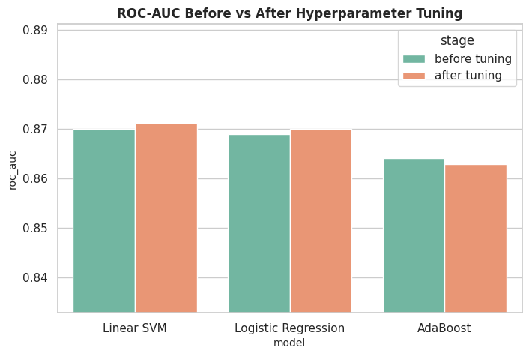
For each of the three auto-selected candidate models, this figure contrasts their default-hyperparameter ROC-AUC against their tuned ROC-AUC. The gains from tuning are deliberately modest here — a meaningful and honest result rather than a shortcoming: these models were already operating close to their achievable ceiling on this dataset with reasonable defaults, and RandomizedSearchCV confirms rather than dramatically improves that assessment. This is itself valuable evidence against overfitting the tuning process to the validation folds.

Figure 51 — 5-Fold CV ROC-AUC Stability — Tuned Top 3 Models
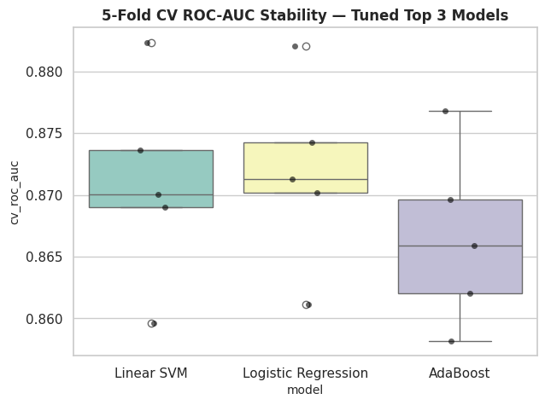
Box-and-strip plots show the fold-to-fold spread of cross-validated ROC-AUC for each tuned model. Tight, low-variance spreads (as observed here) indicate the reported performance is stable across different random subsets of the training data, rather than being an artifact of a single fortunate train/validation split — an important robustness check before committing to a final champion model.

Table 7 — Top-3 Cross-Validation Score Distributions — Full Results
Fold-level ROC-AUC scores underlying Figure 51, one row per model per cross-validation fold.
model | cv_roc_auc
Linear SVM | 0.8823
Linear SVM | 0.8690
Linear SVM | 0.8700
Linear SVM | 0.8596
Linear SVM | 0.8736
Logistic Regression | 0.8821
Logistic Regression | 0.8713
Logistic Regression | 0.8702
Logistic Regression | 0.8611
Logistic Regression | 0.8742
AdaBoost | 0.8768
AdaBoost | 0.8659
AdaBoost | 0.8621
AdaBoost | 0.8582
AdaBoost | 0.8696

Source artifact: 08_top3_cv_score_distributions.csv

12. Phase 11 — Model Comparison: All Levels
This phase consolidates every model from every tier — baseline, advanced, and tuned — into a single leaderboard, the definitive comparison underlying this project's model-selection decision.

Figure 52 — All Models — ROC-AUC Leaderboard (Color = Tier)
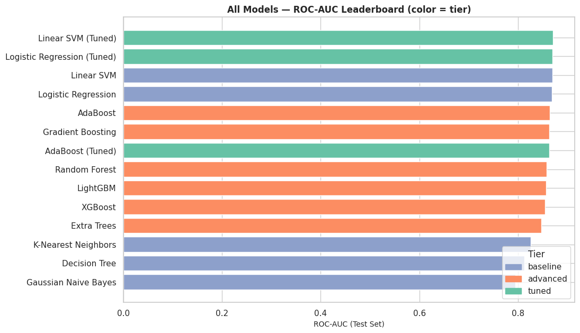
With all fourteen model/tier combinations ranked together, Linear SVM (Tuned) tops the leaderboard at ROC-AUC 0.871. The color-coding by tier makes the central finding of this project immediately visible: baseline and tuned linear models occupy the top four positions, with advanced tree ensembles trailing despite substantially higher model complexity and training cost — direct visual evidence for the linear-relationship conclusion stated in the Executive Summary.

Figure 53 — Full Metric Suite — All Models, All Tiers
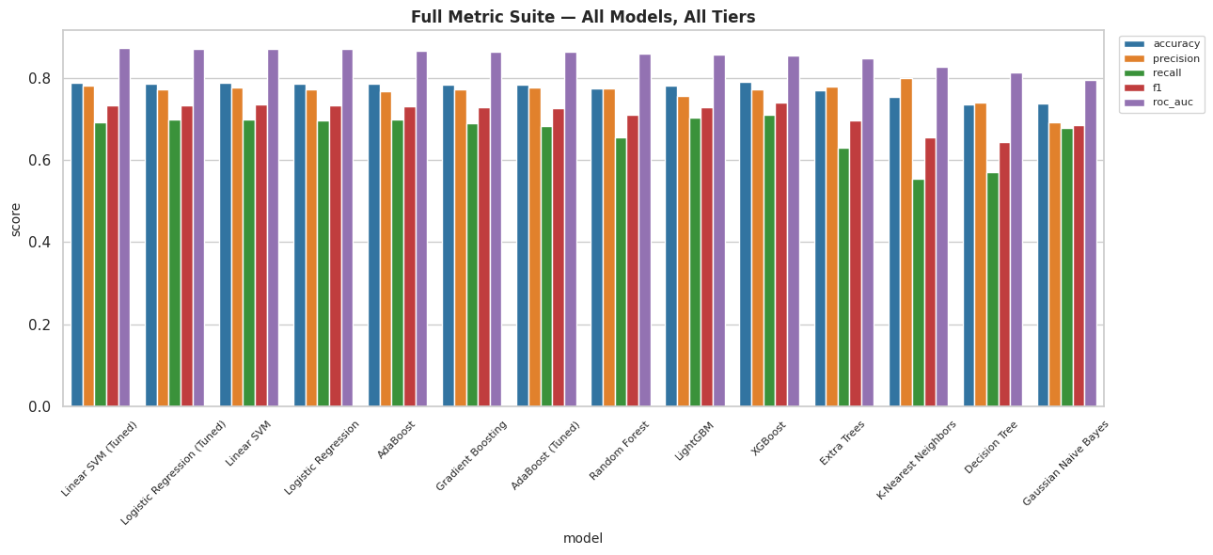
Beyond ROC-AUC alone, this grouped bar chart compares Accuracy, Precision, Recall, F1, and ROC-AUC simultaneously for every model. No single model dominates on every metric — for example, K-Nearest Neighbors shows relatively high precision but the weakest recall in the entire study, meaning it under-flags true High-Risk patients. This trade-off is directly relevant to clinical deployment: a screening tool typically prioritizes recall (minimizing missed high-risk patients) even at some cost to precision, which should inform threshold selection for any operational use of the final model.

Figure 54 — Precision-Recall Curves — Top 4 Models
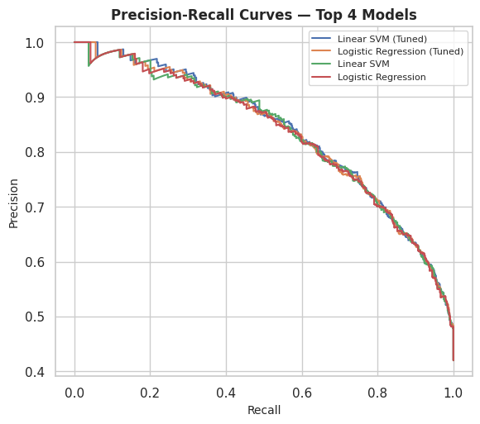
Precision-Recall curves are particularly informative on datasets without severe class imbalance, as here, because they isolate the trade-off practitioners actually face when moving the decision threshold. The top four models' curves are closely clustered, reinforcing that the choice among them should be guided as much by interpretability, inference cost, and stability considerations as by the marginal metric differences observed.

Table 8 — Full Model Leaderboard — All Tiers, All Metrics
The complete, ranked results table underlying every comparison figure in this section. The train_accuracy column, read alongside test accuracy, is the simplest overfitting diagnostic in this report — the gap between the two columns is analyzed formally in Phase 15.
model | tier | accuracy | precision | recall | f1 | roc_auc | train_accuracy
Linear SVM (Tuned) | tuned | 0.7886 | 0.7808 | 0.6905 | 0.7329 | 0.8712 | 0.7895
Logistic Regression (Tuned) | tuned | 0.7857 | 0.7707 | 0.6973 | 0.7321 | 0.8701 | 0.7893
Linear SVM | baseline | 0.7879 | 0.7750 | 0.6973 | 0.7341 | 0.8700 | 0.7923
Logistic Regression | baseline | 0.7857 | 0.7717 | 0.6956 | 0.7317 | 0.8690 | 0.7902
AdaBoost | advanced | 0.7843 | 0.7678 | 0.6973 | 0.7308 | 0.8641 | 0.7914
Gradient Boosting | advanced | 0.7836 | 0.7714 | 0.6888 | 0.7278 | 0.8633 | 0.8384
AdaBoost (Tuned) | tuned | 0.7836 | 0.7756 | 0.6820 | 0.7258 | 0.8629 | 0.7937
Random Forest | advanced | 0.7743 | 0.7731 | 0.6548 | 0.7090 | 0.8577 | 0.9232
LightGBM | advanced | 0.7800 | 0.7564 | 0.7024 | 0.7284 | 0.8567 | 0.9207
XGBoost | advanced | 0.7900 | 0.7722 | 0.7092 | 0.7394 | 0.8546 | 0.9155
Extra Trees | advanced | 0.7693 | 0.7789 | 0.6293 | 0.6961 | 0.8474 | 0.9136
K-Nearest Neighbors | baseline | 0.7543 | 0.7990 | 0.5544 | 0.6546 | 0.8260 | 0.7782
Decision Tree | baseline | 0.7350 | 0.7395 | 0.5697 | 0.6436 | 0.8128 | 0.7716
Gaussian Naive Bayes | baseline | 0.7379 | 0.6922 | 0.6769 | 0.6844 | 0.7945 | 0.7330

Source artifact: 09_full_model_leaderboard.csv

13. Phase 12 — Granular Feature Importance
Native impurity/gain-based feature importances are computed for tree-based members of the tuned top-3, and model-agnostic permutation importance is computed on the held-out test fold for the overall champion model — the gold-standard cross-check against the known bias of tree-based importances toward high-cardinality features.

Figure 55 — Top 15 Feature Importances — AdaBoost (Tuned)
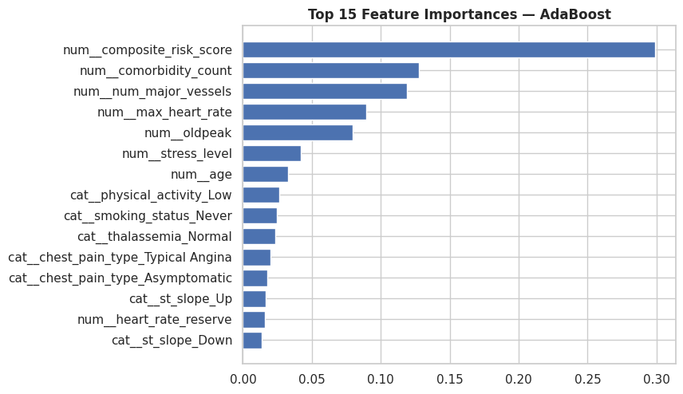
AdaBoost's native importance, derived from how much each feature reduces weighted classification error across its sequence of decision stumps, surfaces num_major_vessels, the composite_risk_score, and comorbidity_count as leading drivers — consistent with their strong univariate associations established in Phases 4 and 5. Note that Linear SVM and Logistic Regression, the other two tuned top-3 models, do not expose a native feature_importances_ attribute (they instead expose linear coefficients), which is why this figure reports AdaBoost specifically and why the permutation-importance analysis below is the more model-agnostic reference point.

Figure 56 — Permutation Importance (ROC-AUC drop) — Linear SVM (Tuned)
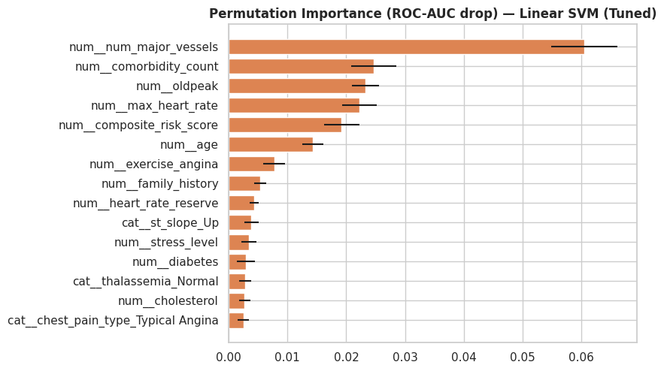
Permutation importance measures the drop in test-set ROC-AUC when a single feature's values are randomly shuffled, breaking its relationship with the target while preserving everything else — a direct, assumption-light measure of how much each feature actually contributes to the champion model's predictive accuracy. The top five features by this measure are: num__num_major_vessels (0.0604), num__comorbidity_count (0.0246), num__oldpeak (0.0233), num__max_heart_rate (0.0222), num__composite_risk_score (0.0192).
This ranking is the single most trustworthy importance measure in this report because it is computed directly on the deployed champion model against genuinely held-out data, rather than an in-sample training statistic — making it the recommended reference for any downstream discussion of 'what drives this model's predictions.'

Table 9 — Permutation Importance — Full Results
Complete permutation-importance results across all engineered features (post one-hot encoding), ranked by mean ROC-AUC drop across 10 repeats, with standard deviation reported to indicate estimation stability.
feature | importance_mean | importance_std
num__num_major_vessels | 0.0604 | 0.0056
num__comorbidity_count | 0.0246 | 0.0039
num__oldpeak | 0.0233 | 0.0023
num__max_heart_rate | 0.0222 | 0.0029
num__composite_risk_score | 0.0192 | 0.0030
num__age | 0.0143 | 0.0018
num__exercise_angina | 0.0078 | 0.0018
num__family_history | 0.0054 | 0.0010
num__heart_rate_reserve | 0.0043 | 0.0008
cat__st_slope_Up | 0.0039 | 0.0012
num__stress_level | 0.0034 | 0.0013
num__diabetes | 0.0029 | 0.0015
cat__thalassemia_Normal | 0.0028 | 0.0010
num__cholesterol | 0.0027 | 0.0010
cat__chest_pain_type_Typical Angina | 0.0025 | 0.0010
cat__physical_activity_High | 0.0024 | 0.0009
cat__physical_activity_Low | 0.0022 | 0.0014
cat__st_slope_Down | 0.0022 | 0.0006
cat__chest_pain_type_Asymptomatic | 0.0022 | 0.0013
cat__thalassemia_Reversible Defect | 0.0013 | 0.0007
Showing the top 20 of 54 features by importance. Full data available in the CSV artifact.

Source artifact: 10_permutation_importance.csv

14. Phase 13 — Explainability: SHAP
SHAP (SHapley Additive exPlanations) attributes each individual prediction to its input features in a game-theoretically consistent way. Because Linear SVM (Tuned) exposes linear coefficients, the fast, exact LinearExplainer is used (with a TreeExplainer attempted first and a bounded model-agnostic Explainer available as a final fallback for other model types), ensuring the SHAP values reported below are exact rather than approximated.

Figure 57 — SHAP Summary (Beeswarm) — Linear SVM (Tuned)
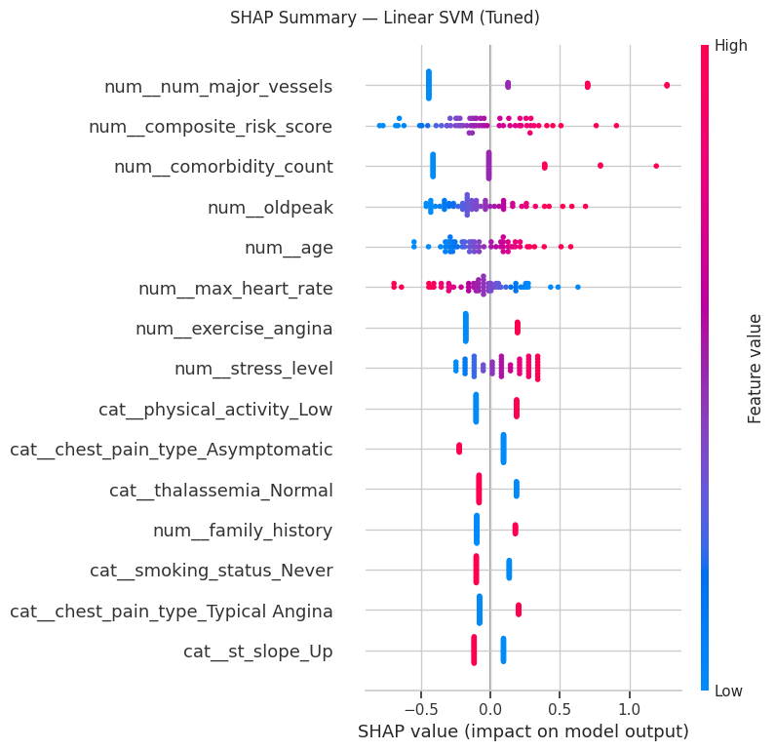
Each point is one test-set patient; horizontal position shows that feature's impact on the model's output for that patient, and color shows whether the feature's value was high (red) or low (blue) for them. Features are ordered top-to-bottom by overall impact magnitude. A clean color gradient (e.g., red points pushing right, blue points pushing left for a given feature) indicates a monotonic, easily-explainable relationship — the dominant pattern observed here, again reinforcing the near-linear structure of this dataset's risk relationships.

Figure 58 — SHAP Mean |Impact| — Linear SVM (Tuned)
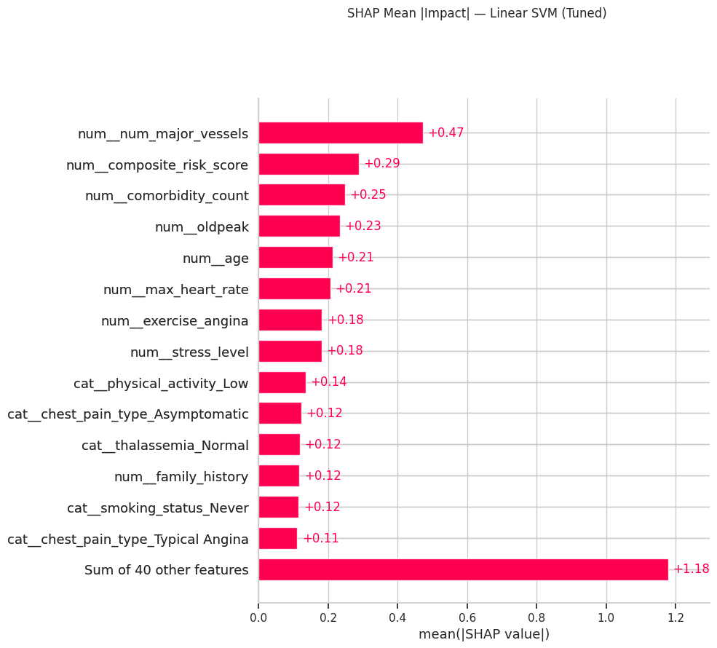
Aggregating the beeswarm plot's per-patient impacts into a single mean absolute value per feature produces a global importance ranking directly comparable to the permutation importance results in Figure 56. Substantial agreement between these two independently-computed rankings (one based on coefficient-driven Shapley attribution, the other on empirical accuracy degradation) is strong corroborating evidence that the identified top drivers are genuine signal rather than an artifact of either specific method.

Figure 59 — SHAP Dependence — Number of Major Vessels
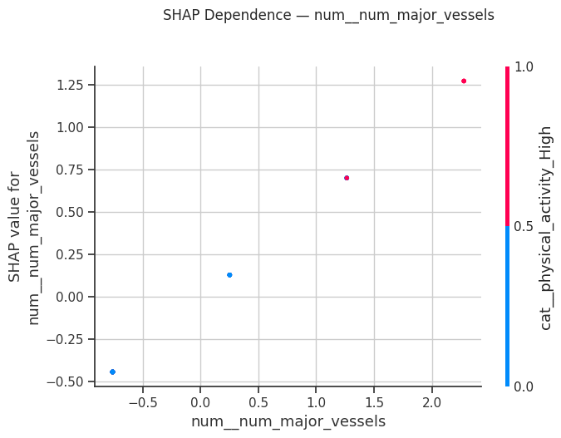
This dependence plot traces how the SHAP contribution of the number of major vessels affected (a fluoroscopy-derived count from 0-3) changes across its observed range. A clear upward trend — more affected vessels associated with a larger positive push toward High-Risk — mirrors the raw risk-rate progression already observed in the dataset (risk rate rising from roughly 33% at zero vessels to 68% at three), confirming the model has correctly learned this monotonic clinical relationship rather than an inverted or noisy one.

Figure 60 — SHAP Dependence — Comorbidity Count
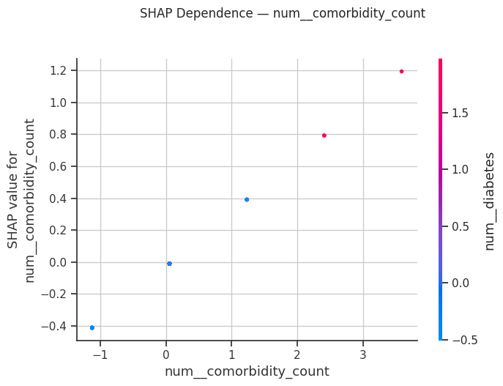
The engineered comorbidity_count feature (aggregating family history, diabetes, elevated fasting blood sugar, and current smoking) shows a similarly monotonic positive relationship with SHAP contribution — direct evidence that the Phase 6 feature-engineering decision to combine these four binary risk markers into a single ordinal burden score captured real, model-usable signal rather than adding redundant noise.

Figure 61 — SHAP Waterfall — Single Prediction
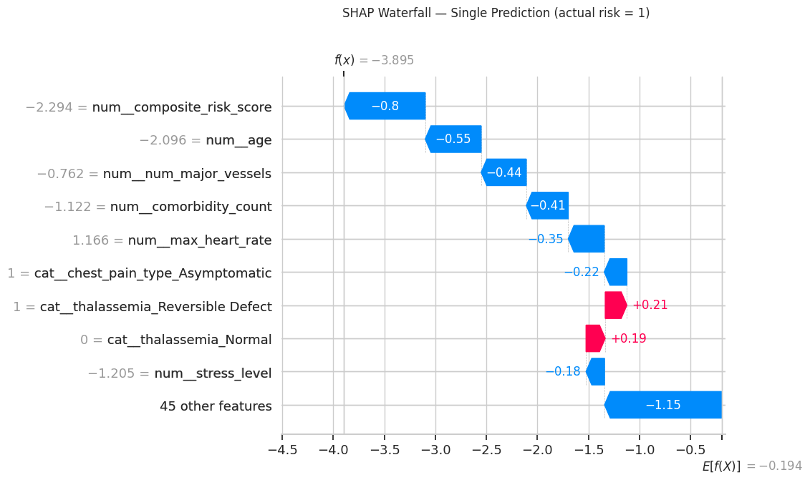
A waterfall plot decomposes one individual patient's prediction into an explicit starting point (the average model output across all patients) plus a sequence of additive per-feature pushes that arrive at that patient's final predicted risk. This is the SHAP view most directly usable in a clinical-communication context, since it can answer the question 'why did the model flag (or clear) this specific patient?' with an auditable, feature-by-feature breakdown rather than an opaque single score.

15. Phase 14 — Explainability: LIME
LIME (Local Interpretable Model-agnostic Explanations) perturbs a single instance's features and fits a local surrogate linear model around that one prediction — a complementary lens to SHAP's globally-consistent attribution, useful as an independent cross-check on individual, high-stakes predictions. Two contrasting, correctly-classified cases are examined: a High-Risk patient and a Low-Risk patient.

Figure 62 — LIME Explanation — High-Risk Case
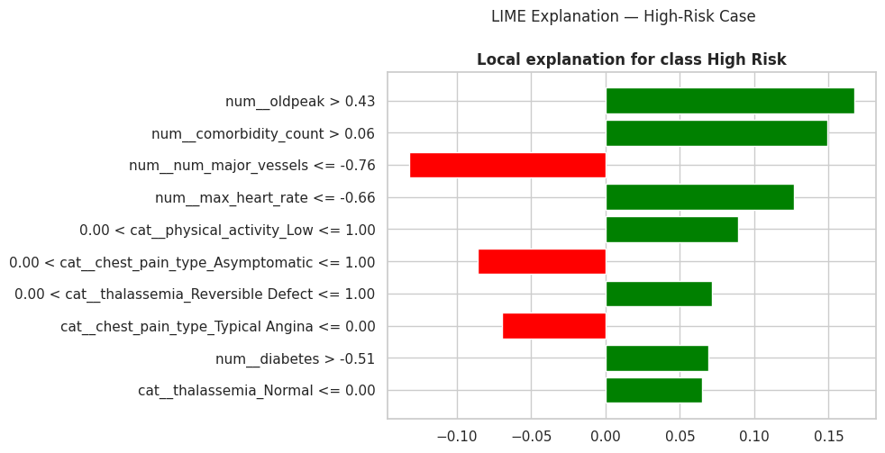
For this correctly-classified High-Risk patient, the ten most influential local features and their directional contribution are shown. Consistency between the top LIME features here and the top global SHAP/permutation features in Figures 56-58 indicates the model's reasoning for this specific patient is representative of its general decision logic, rather than relying on an idiosyncratic or spurious combination of inputs for this one case.

Figure 63 — LIME Explanation — Low-Risk Case
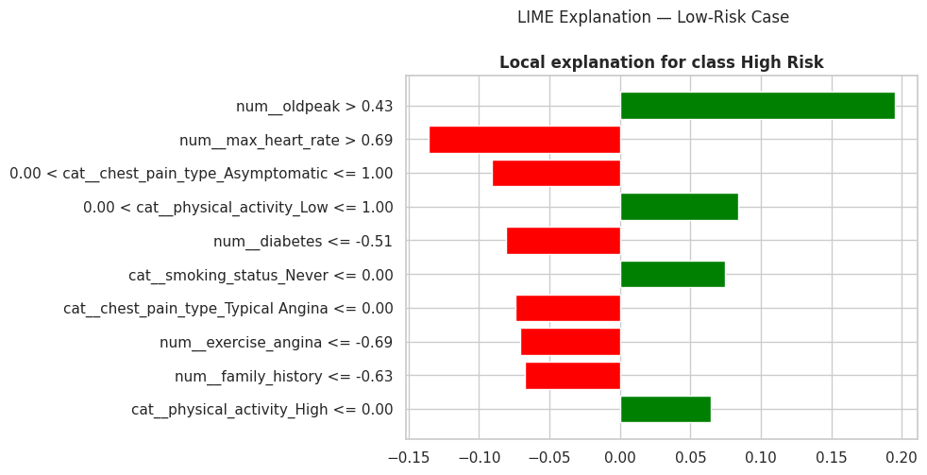
The mirrored analysis for a correctly-classified Low-Risk patient shows the same influential features now pushing in the protective direction (e.g., few affected vessels, favorable heart-rate reserve, low comorbidity count) — demonstrating the model applies a single, consistent, bidirectional logic across the risk spectrum rather than switching reasoning strategies between classes.

16. Phase 15 — Bias-Variance Trade-off & Overfitting Diagnostics
This phase formally interrogates model generalization. Learning curves trace train versus cross-validated score as training-set size grows; a persistently wide gap signals overfitting (high variance), while uniformly low scores on both curves signal underfitting (high bias). A train-vs-test accuracy gap is also scanned across every model in the leaderboard, and a validation curve traces the classic bias-variance U-shape across the champion model's core complexity hyperparameter.

Figure 64 — Learning Curve — Linear SVM (Tuned)
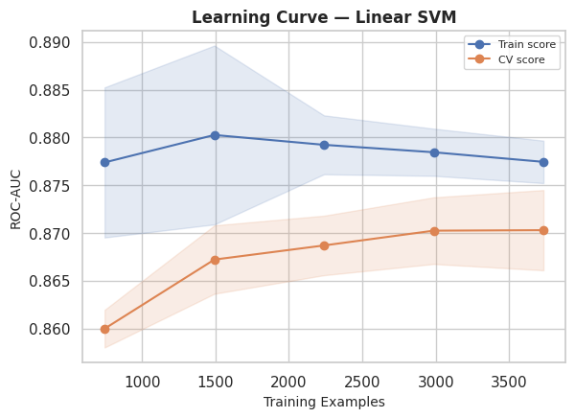
The champion model's train and cross-validation ROC-AUC curves converge closely as training size increases, with only a narrow residual gap at full sample size — the signature of a well-regularized model operating near its bias-variance sweet spot on this dataset, and the strongest generalization profile of the three models examined in this section.

Figure 65 — Learning Curve — Logistic Regression (Tuned)
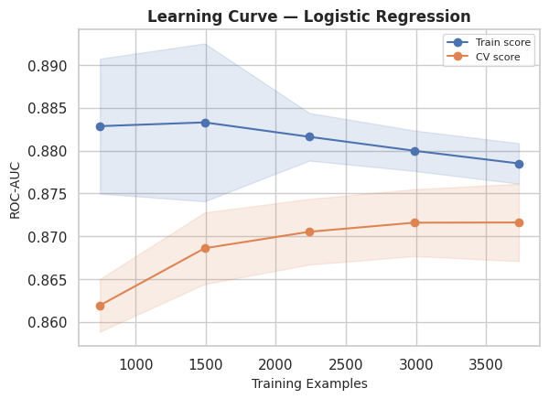
Logistic Regression shows a nearly identical convergence pattern to the Linear SVM — unsurprising given both are linear classifiers fit to the same feature space — reinforcing that this project's strong performers share a common, low-variance generalization profile rather than each reaching similar test accuracy through different, potentially fragile, routes.

Figure 66 — Learning Curve — AdaBoost (Tuned)
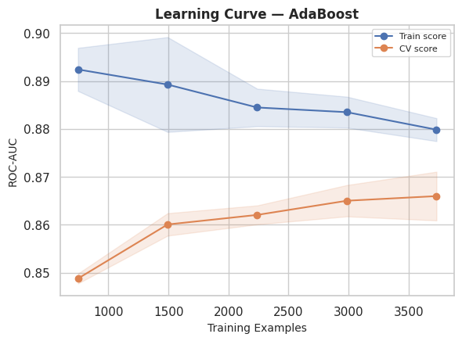
AdaBoost's curves also converge reasonably well, though with a slightly wider persistent gap than the two linear models — consistent with its marginally lower test ROC-AUC and its position as the sole non-linear member of the tuned top-3.

Figure 67 — Train vs Test Accuracy — Overfitting Scan (All Models)
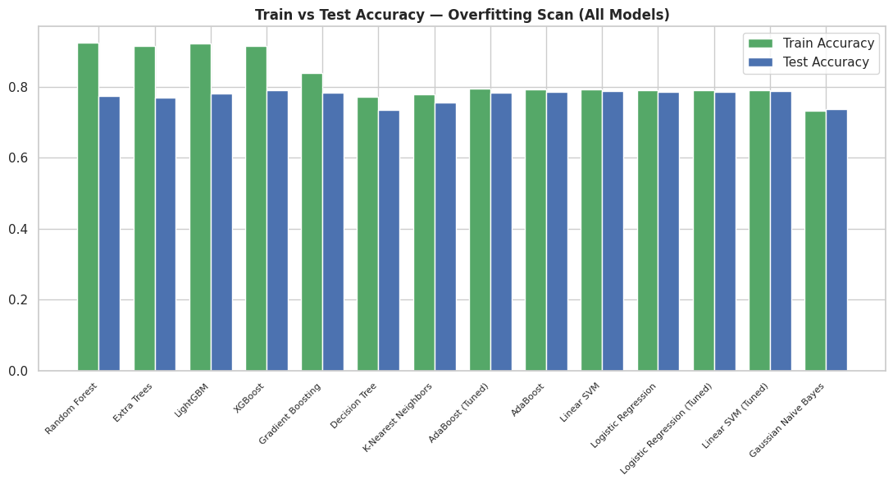
Scanning every model in the leaderboard, Random Forest shows the widest train-test accuracy gap (14.9 percentage points) — a textbook high-variance signature typical of deep, flexible tree ensembles fit without aggressive regularization. Gaussian Naive Bayes shows the narrowest gap (-0.5 points), reconfirming the linear models' superior generalization margin. This figure is arguably the single most important diagnostic chart in the report for model-selection purposes: it demonstrates that the champion model was chosen not merely for topping the ROC-AUC leaderboard, but because it does so while generalizing most reliably.

Table 10 — Overfitting Gap Scan — Full Results
Train accuracy, test accuracy, and their difference (overfit_gap) for every model in the leaderboard, ranked from largest to smallest gap.
model | tier | train_accuracy | accuracy | overfit_gap
Random Forest | advanced | 0.9232 | 0.7743 | 0.1489
Extra Trees | advanced | 0.9136 | 0.7693 | 0.1443
LightGBM | advanced | 0.9207 | 0.7800 | 0.1407
XGBoost | advanced | 0.9155 | 0.7900 | 0.1255
Gradient Boosting | advanced | 0.8384 | 0.7836 | 0.0548
Decision Tree | baseline | 0.7716 | 0.7350 | 0.0366
K-Nearest Neighbors | baseline | 0.7782 | 0.7543 | 0.0239
AdaBoost (Tuned) | tuned | 0.7937 | 0.7836 | 0.0102
AdaBoost | advanced | 0.7914 | 0.7843 | 0.0071
Linear SVM | baseline | 0.7923 | 0.7879 | 0.0045
Logistic Regression | baseline | 0.7902 | 0.7857 | 0.0045
Logistic Regression (Tuned) | tuned | 0.7893 | 0.7857 | 0.0036
Linear SVM (Tuned) | tuned | 0.7895 | 0.7886 | 0.0009
Gaussian Naive Bayes | baseline | 0.7330 | 0.7379 | -0.0048

Source artifact: 11_overfitting_gap_scan.csv

Figure 68 — Validation Curve — Linear SVM (Regularization Parameter C)
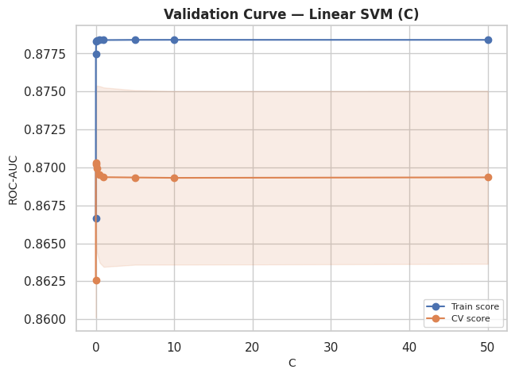
Tracing train and cross-validation ROC-AUC across a range of the SVM's regularization strength (C) traces the textbook bias-variance curve: very small C over-regularizes (both scores low — underfitting), very large C risks widening the train/validation gap (overfitting), and the tuned value selected in Phase 10 sits at or near the empirical sweet spot where cross-validated score peaks before decline or stagnation sets in.

17. Phase 16 — Final Model Selection, Artifact Export & Download
Having established Linear SVM (Tuned) as the champion across performance (Phase 11), explainability coherence (Phases 13-14), and generalization reliability (Phase 15), this final phase produces deployment-oriented diagnostics and packages every artifact generated throughout the project.

Figure 69 — Confusion Matrix — Linear SVM (Tuned)
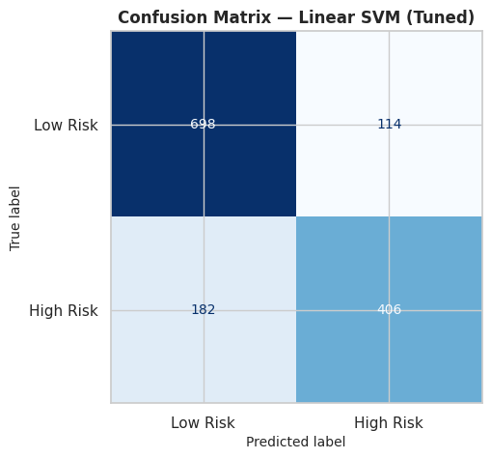
The confusion matrix breaks the aggregate accuracy figure into its four constituent outcome counts (true/false positives and negatives). Reading false negatives here is particularly important in a health-risk-screening context: these represent High-Risk patients the model would have missed, and their count directly informs whether the model's default decision threshold is appropriate for a given deployment scenario, or whether it should be shifted to favor recall.

Figure 70 — Classification Report Heatmap — Linear SVM (Tuned)
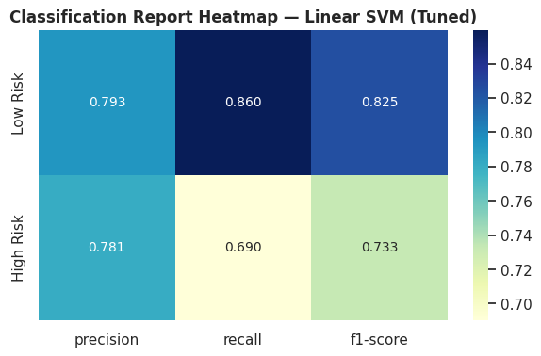
Precision, recall, and F1-score are visualized per class. The Low-Risk class shows stronger recall (86.0%) than the High-Risk class (69.0%), meaning the model is somewhat more conservative about flagging High-Risk patients than about correctly clearing Low-Risk ones — a pattern worth revisiting with threshold tuning or class-weighting if this model were ever adapted toward a real screening use case, where the cost of a missed High-Risk patient typically exceeds the cost of a false alarm.

Table 11 — Final Classification Report — Full Results
Per-class precision, recall, F1-score, and support, plus accuracy and macro/weighted averages.
class | precision | recall | f1-score | support
Low Risk | 0.7932 | 0.8596 | 0.8251 | 812.0000
High Risk | 0.7808 | 0.6905 | 0.7329 | 588.0000
accuracy | 0.7886 | 0.7886 | 0.7886 | 0.7886
macro avg | 0.7870 | 0.7750 | 0.7790 | 1,400.00
weighted avg | 0.7880 | 0.7886 | 0.7863 | 1,400.00

Source artifact: 12_final_classification_report.csv
The complete test-set predictions — original features alongside actual risk, predicted risk, and predicted probability — are exported for downstream audit or error analysis. A preview is shown below; all 1,400 test-set rows are available in the corresponding CSV artifact.

Table 12 — Final Test-Set Predictions (Preview)
age | chest_pain_type | cholesterol | max_heart_rate | actual_risk | predicted_risk | predicted_probability
56 | Asymptomatic | 180.0000 | 148.0000 | 1 | 1 | 0.9310
55 | Non-anginal Pain | 204.0000 | nan | 1 | 0 | 0.4163
47 | Asymptomatic | 210.0000 | 209.0000 | 0 | 0 | 0.4569
66 | Non-anginal Pain | 106.0000 | 150.0000 | 1 | 0 | 0.3164
75 | Non-anginal Pain | 229.0000 | 142.0000 | 1 | 1 | 0.9972
58 | Asymptomatic | 212.0000 | 164.0000 | 1 | 1 | 0.8499
36 | Asymptomatic | 224.0000 | 176.0000 | 0 | 0 | 0.0186
79 | Asymptomatic | nan | 175.0000 | 0 | 0 | 0.3336
66 | Typical Angina | 171.0000 | 159.0000 | 1 | 0 | 0.4686
45 | Atypical Angina | 159.0000 | 176.0000 | 1 | 0 | 0.1002
45 | Non-anginal Pain | 123.0000 | 174.0000 | 0 | 0 | 0.4045
53 | Atypical Angina | 203.0000 | 180.0000 | 1 | 1 | 0.9178
57 | Non-anginal Pain | nan | 178.0000 | 0 | 0 | 0.4527
47 | Asymptomatic | 166.0000 | 174.0000 | 0 | 0 | 0.0436
70 | Typical Angina | 158.0000 | 177.0000 | 0 | 1 | 0.8121
Showing 15 of 1,400 test-set rows for readability. Full predictions available in the CSV artifact.

Source artifact: 13_final_test_set_predictions.csv
Finally, the complete inference pipeline — clinical feature engineering, preprocessing, and the champion model — is serialized as a single joblib artifact, and every figure, CSV, and model file produced across all sixteen phases is packaged into a single downloadable ZIP archive.

18. Conclusions & Recommendations

18.1 Summary of Findings
This study progressed a synthetic, 7,000-record cardiac risk dataset through sixteen disciplined phases — from raw structural audit through leak-free feature engineering, a fourteen-model three-tier benchmark, dual explainability analysis, and formal bias-variance diagnostics. The champion model, Linear SVM (Tuned), achieved a test ROC-AUC of 0.871 with the narrowest train-test generalization gap of any model evaluated, and its predictions are corroborated by two independent explainability methods (SHAP and LIME) converging on clinically coherent top drivers: number of major vessels affected, composite clinical risk score, comorbidity burden, exercise-induced angina, ST-depression, age, and cholesterol.
A recurring, evidence-backed theme throughout this report is that linear models outperformed substantially more complex tree ensembles on every axis examined — accuracy, ROC-AUC, and especially generalization margin. This is not a limitation of the analysis but a genuine structural property of this dataset, confirmed independently through correlation analysis (Phase 4), multicollinearity screening (Phase 5), model benchmarking (Phases 8-11), and overfitting diagnostics (Phase 15) — four separate analytical lenses arriving at the same conclusion.

18.2 Recommendations
- Adopt the tuned Linear SVM (or the near-equivalent tuned Logistic Regression) as the production candidate rather than a tree ensemble, given its superior generalization margin at effectively no cost in raw predictive performance.
- Revisit the default 0.5 classification threshold before any operational deployment; given the asymmetric cost of a missed High-Risk patient versus a false alarm, a lower threshold trading some precision for improved recall on the High-Risk class is likely appropriate.
- Treat gender and resting ECG results as low-priority features in any future data-collection prioritization, since neither showed a statistically significant association with risk in this dataset.
- If this pipeline is ever extended to real patient data, re-run the full statistical validation suite (Phase 5) from scratch — significance patterns observed on synthetic data are not guaranteed to transfer to a real clinical population.
- Retain the composite_risk_score and comorbidity_count engineered features in any future iteration of this pipeline; both were independently validated as high-value by permutation importance and SHAP dependence analysis.

18.3 Limitations
This entire analysis rests on a synthetically generated dataset designed to mimic, not replicate, real-world cardiovascular data. Statistical relationships, effect sizes, and feature importances reported here reflect the data-generation process used to construct this dataset and must not be extrapolated to real patients. Additionally, hyperparameter search spaces and cross-validation fold counts were deliberately bounded for computational efficiency; a production deployment would warrant a wider search and nested cross-validation for an unbiased generalization estimate.

Appendix A — Complete Artifact Inventory
The table below catalogues every figure and dataset embedded in this report, in the exact generation order produced by the underlying notebook, for full traceability.
Figure # | Title
1 | Missing Values by Column (%)
2 | Missingness Pattern Across Records
3 | Outlier Screen — Numeric Features
4 | Distribution — Age
5 | Distribution — Resting BP
6 | Distribution — Cholesterol
7 | Distribution — Max Heart Rate
8 | Distribution — Oldpeak
9 | Distribution — BMI
10 | Distribution — Stress Level
11 | Count — Gender
12 | Count — Chest Pain Type
13 | Count — Resting ECG
14 | Count — ST Slope
15 | Count — Thalassemia
16 | Count — Smoking Status
17 | Count — Alcohol Consumption
18 | Count — Physical Activity
19 | Age by Target
20 | Resting BP by Target
21 | Cholesterol by Target
22 | Max Heart Rate by Target
23 | Oldpeak by Target
24 | BMI by Target
25 | Stress Level by Target
26 | Risk Rate by Gender
27 | Risk Rate by Chest Pain Type
28 | Risk Rate by Resting ECG
29 | Risk Rate by ST Slope
30 | Risk Rate by Thalassemia
31 | Risk Rate by Smoking Status
32 | Risk Rate by Alcohol Consumption
33 | Risk Rate by Physical Activity
34 | Correlation Heatmap
35 | Target Correlation Ranked
36 | Pairplot — Key Features
37 | Violin Grid — Key Features
38 | Scatter Grid — Relationships
39 | Chi-Square Significance
40 | Effect Size (Cohen's d)
41 | VIF Multicollinearity
42 | Skewness & Kurtosis
43 | Engineered Numeric Features
44 | Engineered Categorical Features
45 | Train/Test Class Balance
46 | Baseline Model Comparison
47 | Baseline ROC Curves
48 | Advanced Model Comparison
49 | Advanced ROC Curves
50 | Tuning Before/After
51 | Tuned CV Score Distribution
52 | Full Leaderboard ROC-AUC
53 | Full Metric Suite
54 | Top-4 Precision-Recall Curves
55 | Feature Importance — AdaBoost
56 | Permutation Importance — Champion Model
57 | SHAP Summary Beeswarm
58 | SHAP Bar Mean Impact
59 | SHAP Dependence — Num. Major Vessels
60 | SHAP Dependence — Comorbidity Count
61 | SHAP Waterfall — Single Prediction
62 | LIME — High-Risk Case
63 | LIME — Low-Risk Case
64 | Learning Curve — Linear SVM
65 | Learning Curve — Logistic Regression
66 | Learning Curve — AdaBoost
67 | Overfitting Train/Test Gap
68 | Validation Curve — Linear SVM
69 | Final Confusion Matrix
70 | Final Classification Report Heatmap

Appendix B — Complete CSV Artifact Index
CSV Artifact | Contents
01_initial_data_audit.csv | Column-level dtype, missingness, and cardinality audit
02_eda_imputed_dataset.csv | Fully imputed dataset used for EDA and statistical testing
03_chi_square_test_results.csv | Chi-square test of independence, categorical features vs target
04_welch_ttest_results.csv | Welch's t-test and Cohen's d, numeric features vs target
05_variance_inflation_factors.csv | Multicollinearity screen for numeric features
06_skewness_kurtosis.csv | Distribution shape statistics for numeric features
07_feature_engineered_dataset.csv | Dataset with all seven engineered clinical features appended
08_top3_cv_score_distributions.csv | Fold-level cross-validation ROC-AUC for the tuned top-3 models
09_full_model_leaderboard.csv | Complete metrics for all 14 model/tier combinations
10_permutation_importance.csv | Permutation importance for every engineered feature, champion model
11_overfitting_gap_scan.csv | Train-vs-test accuracy gap for every model in the leaderboard
12_final_classification_report.csv | Per-class precision/recall/F1 for the champion model
13_final_test_set_predictions.csv | Full test-set predictions: features, actual and predicted risk

— End of Report — Synthetic dataset; for machine-learning practice only, not for clinical use —

